Machine Learning & Data Science
Consolidated & Corrected Notes
Organized in learning order • Errors corrected • Missing concepts added • Tricky interview Q&A included
Compiled from workbook sheets: ML, theory_01, theory_02, theory_03, classi, Git, Losses, Grad-D

How to Read This Document
Your original notes from all Excel sheets have been merged, reordered into a logical learning sequence, simplified, and expanded. The latest additions on loss functions and gradient-descent optimizers (SGD, Momentum, Nesterov, Adagrad, RMSProp, Adam) have been folded into Part 7 in the correct order. All images from the workbooks are kept and placed inside their correct topics; broken/black images have been repaired. Three kinds of highlighted boxes are used:
✔ Correction (yellow) — something in the original notes was wrong or misleading and has been fixed. Read these carefully; they are common interview traps.
＋ Added concept (green) — an important concept that was missing from the notes for that topic.
Q: Tricky Interview Questions — at the end of each part: only questions where people genuinely get confused. Simple questions were deliberately left out.

Summary of corrections made to the original notes
Topic | What was corrected
Bias & Variance | "Bias = training error, Variance = testing error" replaced with the correct definitions (model simplicity vs sensitivity to training data).
Entropy / Gini ranges | "Entropy is between 0 and 1" and "Gini 0 to 0.5" hold only for BINARY classification; general maxima are log2(k) and 1 − 1/k.
R-squared range | R² in [0,1] holds on training data with an intercept; on test data R² can be negative.
Weighted Cross-Entropy | Direction of the alpha parameter was reversed; alpha > 1 on the positive term penalizes false negatives more.
range(5) as Iterator | range is an iterable, not an iterator; isinstance(range(5), Iterator) is False.
git restore | restore does not move staging → repository (that is commit); it discards working changes / unstages with --staged.
git remote -V | Flag is lowercase: git remote -v.
Isolation Forest contamination | Flags the top-X% most anomalous points (highest scores / shortest paths), not the "bottom X%".
CNN under-sampling | Clarified CNN = Condensed Nearest Neighbour, not Convolutional Neural Network.
Optimizer / loss images | Several formula images (RMSProp, Adam, optimizer comparison table) imported as black boxes due to transparency; flattened onto a white background so they are readable.
Linear regression assumptions | Linearity and independence of errors were missing; multicollinearity detection (VIF) added.

Table of Contents

Part 1 — Python & Programming Foundations
These are the computer-science basics that interviewers use to check if you understand how Python actually works, not just how to write it.

1.1 Compiler vs Interpreter (and how Python really runs)
Both a compiler and an interpreter translate high-level code into low-level code. The difference is when and how much at a time.
- Compiler: translates the ENTIRE program into machine code first, then runs it. Execution is very fast. Examples: C, C++, Rust, Go.
- Interpreter: translates and runs the code line-by-line / statement-by-statement. Examples: Ruby, PHP, JavaScript (in some contexts).
Python is both compiled AND interpreted. When you run a .py file: (1) the CPython compiler converts your source code to Bytecode (.pyc files in the __pycache__ folder). Bytecode is NOT machine code — it is a low-level, platform-independent set of instructions. (2) The Python Virtual Machine (PVM) then interprets this bytecode line-by-line on your CPU.
Simple example
Compiler = translating an entire book into Hindi first, then handing the full translated book to the reader (fast reading later).
Interpreter = a live translator who translates each sentence as the speaker says it (slower, but starts immediately).

Compile time vs Run time
- Compile time: when the code is being translated into low-level/byte code.
- Run time: when the translated code is actually executing and doing its job.

Python implementations
- CPython: the default "reference implementation", written in C. Compiles to bytecode, run by the CPython VM.
- Jython: written in Java. Compiles Python to Java bytecode so it runs on the JVM and can use Java libraries.
- IronPython: written in C# ("C-Sharp"). Runs on the .NET CLR.
- PyPy: written in RPython. Uses Just-In-Time (JIT) compilation: it watches your program while running, converts "hot" (frequently used) code into fast machine code, so after warming up the same code runs much faster.

1.2 Python Objects & Memory Management
Every object in Python contains three essential fields:
- Value: the actual data (e.g., the number 42).
- Type: defines what the object can do (int, str, list...).
- Reference count: an internal counter of how many names/variables currently point to this object.
Python stores all objects in a Private Heap. You never allocate memory manually (unlike C++) — Python’s Memory Manager handles it (dynamic allocation).
Integer Interning: if you write x = 10 and y = 10, Python usually does NOT create two objects. Both x and y point to the SAME memory address of the integer 10 (small integers are cached/reused).

How Python frees memory (two layers)
- Layer 1 — Reference Counting (primary): when an object’s reference count drops to 0, its memory is freed immediately.
- Layer 2 — Generational Garbage Collection (secondary): catches objects involved in reference cycles (e.g., two objects pointing at each other) that reference counting alone cannot free.
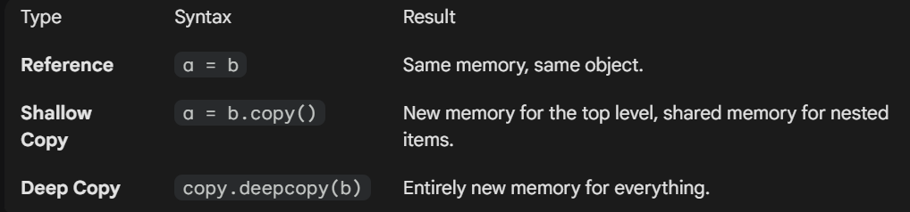
Reference vs Shallow Copy vs Deep Copy — how memory is shared
Copy example in one line each
b = a → same object, same memory. Changing b changes a.
b = a.copy() → shallow copy: new outer object, but nested items are still shared.
b = copy.deepcopy(a) → entirely new memory for everything.

1.3 Hash Tables (why dictionaries are fast)
A hash table stores data as key–value pairs. Three parts:
- Key: the input (e.g., a username or product ID).
- Hash function: a math formula that turns the key into a specific number (an index).
- Bucket (array): a fixed-size list where the data is actually stored at that index.
Average lookup time complexity is O(1) — constant time. This works because RAM ("Random Access Memory") is built so that accessing ANY memory address takes the same amount of time.
Example
You ask for d["ravi"]. Python hashes "ravi" → gets index 7 → jumps straight to slot 7. It does NOT scan the whole dictionary, which is why dict lookup beats searching a list.

1.4 Multithreading, Multiprocessing & Asyncio

Hardware basics first
- Socket: the physical slot on the motherboard where a CPU (processor) is installed. A computer can have one or more sockets.
- Core: an individual processing unit inside the CPU. Each core executes one task at a time; a multi-core CPU runs multiple tasks truly simultaneously.
Example
2 sockets × 14 cores each = 28 cores → up to 28 independent tasks at the same time (if the software supports it). Lacking CPU → program runs slow. Lacking RAM → program may crash.

CPU-bound vs I/O-bound
- CPU-bound: spends most time computing (e.g., matrix multiplication, image processing).
- I/O-bound: spends most time WAITING for input/output (e.g., reading files, downloading from a website, database calls).

Process vs Thread
- Process: an independent running program with its OWN memory space. Does not share memory with other processes. Heavier, but safer (memory isolation). One process can contain many threads.
- Thread: a smaller unit of execution INSIDE a process. Threads share memory with each other, so they are lighter and faster to create. Best for tasks that wait (I/O).

The GIL (Global Interpreter Lock)
In CPython, the GIL allows only ONE thread to execute Python bytecode at a time, even on multi-core CPUs. So Python threads do NOT speed up CPU-bound work. Python switches threads very fast (default switch interval ≈ 5 ms in Python 3.7–3.10), creating an illusion of parallelism.
- The GIL is temporarily RELEASED when a thread does blocking I/O (reading/writing a file, network call) — so other threads can run while one waits. This is why threads are still useful for I/O-bound tasks.
- Jython and IronPython do not have a GIL.

Multiprocessing
- Each process has its own memory space, its own Python interpreter, and its OWN GIL — so multiprocessing bypasses the GIL and gives TRUE parallel execution on multi-core machines.
- Cost: processes do not share memory by default; sharing data needs special mechanisms (Pipes, Queues) and is slower.
- Inside each process, multiple threads can still exist, but per process only one thread runs Python code at a time.

Asyncio
asyncio lets a SINGLE thread manage many tasks cooperatively — like a task manager that switches to another task whenever the current one is waiting. Use it for waiting-heavy work, not heavy calculation.
- async def → "this function (a coroutine) can be paused and resumed"
- await → "pause here and let other tasks run while we wait"
- asyncio.run() → "start the whole async engine"
Breakfast example (classic)
Eggs take 3 min, pancakes 5 min, coffee 2 min.
Sequential cooking = 3+5+2 = 10 min.
With asyncio.gather(make_eggs(), make_pancakes(), make_coffee()) all three "cook" together → total ≈ 5 min (the longest task), because while one is waiting, the others progress.

Use case | Best tool | Why
Heavy calculation (CPU-bound) | Multiprocessing | Bypasses GIL → true parallelism
Many file/network waits (I/O-bound) | Threading or asyncio | GIL released during I/O / cooperative switching
Thousands of network requests | asyncio | One thread, very low overhead

1.5 Iterables vs Iterators
- Iterable: any object you can loop over — list, tuple, dict, string. It has __iter__() but NOT __next__(). A list is iterable, not an iterator.
- Iterator: an object representing a STREAM of data. It follows lazy evaluation — it does not store the whole collection in memory; it produces the next item only when you ask. Must implement BOTH __iter__() and __next__(). Created with iter(); values pulled with next().
- When an iterator is exhausted, Python raises StopIteration.
Why iterators matter (memory)
numbers = [i for i in range(1_000_000)] → builds a HUGE list in memory.
numbers = range(1_000_000) → an iterator-like object: tiny, constant memory.
File objects are iterators: you can scan a 10 GB log file line-by-line without ever loading it fully into RAM.

from collections.abc import Iterator
isinstance(range(5), Iterator) # False (range is iterable, iter(range(5)) is the iterator)
isinstance(iter([1,2,3]), Iterator) # True
isinstance([1, 2, 3], Iterator) # False
✔ Correction: The original note said isinstance(range(5), Iterator) is True. Actually range is an ITERABLE (lazy, memory-efficient) but technically NOT an Iterator — it has no __next__(). Calling iter(range(5)) gives you the iterator. This exact distinction is a favourite interview trap.
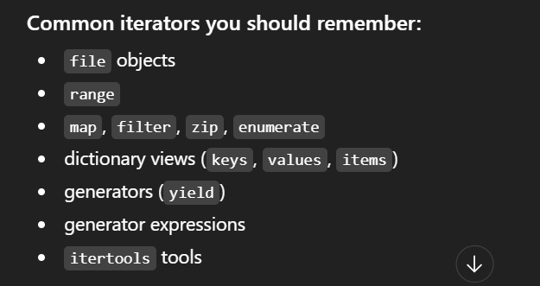
Common iterators/iterable tools worth remembering

1.6 Generators
A generator is a special, easier way to create an iterator. All generators are iterators, but not all iterators are generators. Generators exist because writing iterators by hand (writing __iter__ and __next__ yourself) is painful and error-prone — generators give the same power with far less code.

Two ways to create one
- Generator expression: k = (i for i in range(1, 10)) → note the round brackets (). The generator object k stays tiny and constant in size no matter how big the range is.
- Generator function: any function containing the yield keyword. Calling it does NOT run the code — it returns a generator object.
yield vs return: return kills the function. yield PAUSES it — the function’s state is saved, and when next() is called again it resumes exactly where it left off. When exhausted, it raises StopIteration (same as iterators).
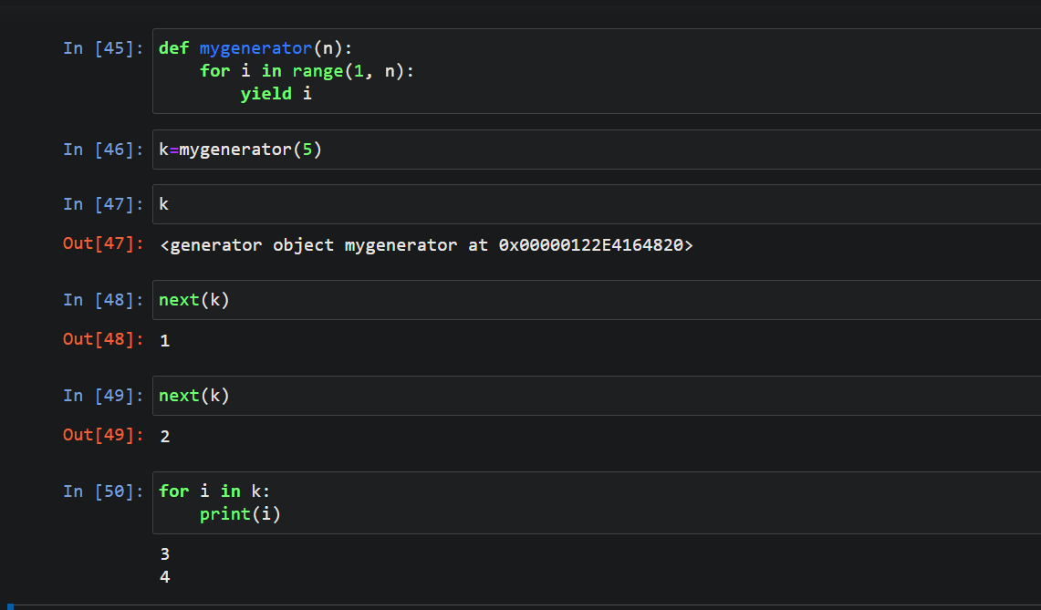
Generator function with yield — created, advanced with next(), then finished with a loop

1.7 Decorators
A decorator is a function that takes another function as input and extends its behaviour without modifying its source code. You attach it with @decorator_name above the function definition. Use it when you don’t want to change the function but want to add extra functionality (e.g., measure how long it takes, log calls, validate inputs).

Anatomy
- Outer function: receives the original function.
- Wrapper (inner function): takes the arguments (*args, **kwargs), does extra work, calls the original function, returns the result.
- Return: the outer function returns the wrapper — effectively replacing the original function with a smarter version.
- Stacking: multiple decorators can be applied. The output of the bottom decorator becomes the input of the one above it.
Example — auto-convert string arguments to integers
@convert_to_int_dec
def addition(a, b): return a + b
addition("10.7", "20.2") # decorator converts → 10 + 20 → 30
The decorator pre-processes the arguments (str → float → int) before the real function runs.

1.8 ASCII, Unicode and UTF-8
- ASCII: only 128 characters — English letters, digits, basic symbols.
- Unicode: a global standard assigning a unique number (code point) to EVERY character — 137,000+ including English, Hindi, Chinese, Japanese and emojis. Think of it as a massive ASCII table.
- UTF-8: an ENCODING system for Unicode — it translates any Unicode character into a unique binary string so it can be stored in files. UTF-16 does the same job differently; the two are not compatible with each other.
Why convert bytes (UTF-8) back to Unicode strings? Because humans and Python logic work with characters, not raw bytes.
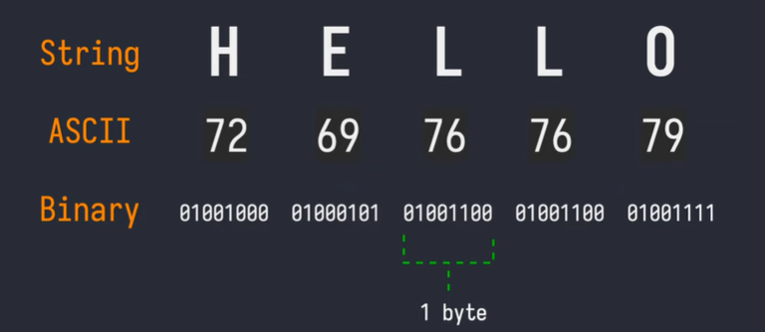
String → ASCII codes → binary: how "HELLO" becomes bytes
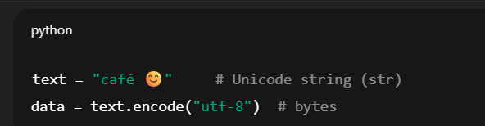
Encoding a Unicode string to UTF-8 bytes in Python

1.9 Regular Expressions — quick reference
Pattern | Meaning
[ ] | character set (any one of these)
[^ ] | NOT these characters
^ / $ | start of string / end of string
. | any character except newline
* / + / ? | 0 or more / 1 or more / 0 or 1
{m,n} | between m and n repetitions
\d / \D | digit / non-digit
\s / \S | whitespace / non-whitespace
\w / \W | word character / non-word character
\b / \B | word boundary / not a word boundary

1.10 Missing Values: NaN vs None
- NaN ("Not a Number"): a missing FLOATING-POINT value. Any arithmetic with NaN gives NaN. Created with float("nan"), math.nan or np.nan. NumPy provides NaN-ignoring aggregations (np.nansum, np.nanmean...).
- None: a Python OBJECT of type NoneType.
- Pandas treats the two nearly interchangeably and automatically converts None to NaN inside numeric columns.
The classic trap
None == None → True
np.nan == np.nan → False! (NaN is never equal to anything, even itself — use pd.isna() / np.isnan() to test)

Tricky Interview Questions — Part 1
Q: Python has a GIL, so threads can’t run in parallel. Why do people still use threading in Python?
Because the GIL is released during blocking I/O. While one thread waits for a file or network response, another thread runs. So threading speeds up I/O-bound programs a lot — it just doesn’t help CPU-bound programs (use multiprocessing for those).
Q: Is Python compiled or interpreted?
Both. Source code is first compiled to bytecode (.pyc), then the Python Virtual Machine interprets that bytecode line-by-line. Saying only "interpreted" is incomplete.
Q: What is the difference between an iterable, an iterator and a generator?
Iterable = can be looped over (has __iter__). Iterator = produces values one at a time with __next__ (lazy stream). Generator = the easy way to BUILD an iterator, using yield or (x for x in ...). Every generator is an iterator; not every iterator is a generator; a list is iterable but neither.
Q: Why does np.nan == np.nan return False?
By the IEEE-754 floating point standard, NaN is defined as not equal to anything, including itself. That is why we must use pd.isna()/np.isnan() instead of == to detect missing values.
Q: If two variables x = 10 and y = 10, are they the same object?
Usually yes — small integers are interned (cached), so both names point to the same memory address. This is an optimization detail of CPython, and it is why "is" can behave surprisingly: use == for value comparison, "is" only for identity.

Part 2 — Core Machine Learning Concepts

2.1 Parametric vs Non-Parametric Models
 | Parametric | Non-Parametric
Number of parameters | Fixed (decided before training) | Flexible (grows with data)
Speed / simplicity | Simple and fast | Can learn complex patterns
Data needed | Less | More
Examples | Linear Regression, Logistic Regression | KNN, Decision Trees, SVM
Example
Linear regression always learns exactly one slope per feature plus one intercept — fixed parameters → parametric. KNN keeps the whole training set and its "shape" grows with the data → non-parametric.

2.2 Lazy Learners vs Eager Learners
- Lazy learner: does NO training upfront — it just stores the training data and computes at prediction time. Training: fast. Prediction: slow. Example: KNN. "It waits until you ask a question, then learns just enough to answer it."
- Eager learner: builds a model during training, then predicts quickly. Training: slow. Prediction: fast. Examples: Decision Trees, Naive Bayes, Neural Networks.

2.3 Generative vs Discriminative Classifiers
- Discriminative ("boundary seekers"): learn the BOUNDARY between classes. They don’t care what makes an apple an apple — only where apples stop and oranges begin. Examples: Logistic Regression, SVM, Decision Trees/Random Forest, traditional Neural Networks.
- Generative ("pattern builders"): learn the DISTRIBUTION of each class — what an apple looks like on its own and what an orange looks like on its own. Examples: Naive Bayes, GANs.

2.4 Bias, Variance, Overfitting & Underfitting
✔ Correction: The original note said "Bias means error of training data, Variance means error of testing data." That is a common but incorrect shortcut. Correct definitions below — this is one of the most frequently mis-answered interview questions.
- Bias: error caused by overly SIMPLE assumptions in the model — the model cannot capture the true pattern even on training data. High bias → underfitting.
- Variance: error caused by the model being too SENSITIVE to the particular training set — a small change in training data produces a very different model. High variance → overfitting.
- How it shows up: overfitting = low TRAINING error but high TEST error (the gap between them is the symptom of high variance). Underfitting = high error on training data itself.
- Trade-off: we want a good balance — neither overfitting nor underfitting. Making a model more complex lowers bias but raises variance, and vice-versa.
Example
Fitting house prices with a straight line when the true relation is curved → high bias (underfit: bad even on training data).
Fitting a degree-15 polynomial through every training point → high variance (overfit: perfect on training, terrible on new houses).

2.5 fit(), transform(), fit_transform() & Data Leakage
- fit() → LEARN parameters (e.g., a scaler learns the mean and std of the training data).
- transform() → APPLY the learned parameters to data.
- fit_transform() → both together, in one step.
Golden rule: NEVER fit on test data. Fit on training data only, then only transform the test data. Fitting on test data lets information from the test set "leak" into the model — this is called data leakage and produces dishonestly good results.
Example
scaler.fit_transform(X_train) ✔ learn mean/std from train and scale train
scaler.transform(X_test) ✔ scale test using the TRAIN statistics
scaler.fit_transform(X_test) ✘ leakage — the model has "seen" the test distribution

2.6 Train/Test Split & Cross-Validation
＋ Added concept: Your notes used train/test ideas everywhere but never defined them — interviewers almost always ask this, so it is added here.
- Train/test split: hold out a portion of data (commonly 20–30%) that the model never sees during training, and measure performance on it. This estimates how the model behaves on genuinely new data.
- K-Fold Cross-Validation: split data into K equal folds (commonly K = 5 or 10). Train on K−1 folds, test on the remaining fold; repeat K times so every fold is tested once; average the K scores. Gives a more stable performance estimate than a single split, especially for small datasets.
- Stratified K-Fold: same idea, but each fold keeps the same class proportions as the full dataset — important for imbalanced classification.
Example (5-fold)
1,000 rows → 5 folds of 200. Round 1: train on folds 2–5, test on fold 1. Round 2: train on 1,3,4,5, test on fold 2 ... Average of the 5 test scores = your reported accuracy.

Tricky Interview Questions — Part 2
Q: A model has 99% training accuracy and 65% test accuracy. Bias problem or variance problem?
Variance (overfitting). The big gap between training and test performance is the signature of high variance. Fixes: more data, regularization, simpler model, ensembling (bagging).
Q: Why must the scaler be fit only on training data?
Because the test set must simulate truly unseen future data. If the scaler’s mean/std include test rows, information about the test distribution leaks into preprocessing, inflating the measured performance — data leakage.
Q: Is KNN training really "free"?
Training is essentially just storing the data (lazy learner) — but you pay at prediction time: each prediction computes distance to ALL training points, which is expensive for large datasets. So "no training cost" does not mean "cheap model".

Part 3 — Feature Engineering & Data Preparation
Feature engineering is the process of selecting, manipulating and transforming raw data into features. Fewer, better features reduce complexity and training time; very high dimensions make patterns harder to find.

3.1 Types of Categorical Data & Encoding
- Ordinal data: categories WITH a natural order — e.g., education level (High School < Bachelor < Master < PhD).
- Nominal data: categories WITHOUT any order — e.g., city names, colours.

Encoding techniques
- One-Hot Encoding: one new 0/1 column per category. Use for NOMINAL data. Practical: fine when categories are limited (e.g., fewer than ~50); never replace nominal categories with plain numbers 1, 2, 3 — the model would wrongly learn that 2 > 1.
- Label Encoding: assigns arbitrary integers with no control over order. Risky for input features of linear/distance models (implies fake order), but for the TARGET y in classification it is NOT harmful — the model treats those numbers as class IDs, not magnitudes.
- Ordinal Encoding: integers that respect a meaningful order you define — correct choice for ordinal data.
- MultiLabelBinarizer (sklearn): when one cell holds multiple labels (e.g., a movie tagged "Action, Comedy"), each label becomes its own column: 1 = present, 0 = not present.
Example
City ∈ {Delhi, Mumbai, Pune} → one-hot → Is_Delhi, Is_Mumbai, Is_Pune.
Education ∈ {School, Bachelor, Master} → ordinal → 0, 1, 2 (order is real).
Genres = "Action|Comedy" → MultiLabelBinarizer → Action=1, Comedy=1, Drama=0.

3.2 The Dummy Variable Trap
After one-hot encoding, one dummy column can be PERFECTLY predicted from the others. Example with two categories Dog/Cat: if Is_Dog = 0 you know with 100% certainty Is_Cat = 1 — they are perfectly correlated. This creates perfect multicollinearity, which breaks the math of linear models.
Escape: the n−1 rule. Always drop one dummy column (e.g., drop Is_Cat; "both zeros" then means Cat). In pandas: pd.get_dummies(df, drop_first=True).

3.3 Feature Scaling — who needs it and who doesn’t
- MUST scale: gradient-descent-based models (Logistic Regression, Neural Networks) and distance-based models (KNN, K-Means, SVM). Otherwise a feature like salary (in lakhs) totally dominates a feature like age.
- NO need to scale: tree-based models (Decision Tree, Random Forest, Gradient Boosting). Trees only ask "is feature > threshold?" — the answer doesn’t change if you rescale.
＋ Added concept: The two standard scaling methods (worth naming explicitly in interviews): Standardization (StandardScaler): z = (x − mean)/std → mean 0, std 1; not bounded; less hurt by outliers than min-max. Normalization (MinMaxScaler): (x − min)/(max − min) → squeezes into [0, 1]; very sensitive to outliers. RobustScaler uses median and IQR, so it is the safest when outliers are present.

3.4 Handling Imbalanced Datasets
Drawback of imbalance: the model becomes biased toward the majority class and accuracy becomes misleading (a model predicting "not fraud" for everyone gets 99% accuracy on a 1%-fraud dataset).

1) Under-sampling — Condensed Nearest Neighbour (CNN)
✔ Correction: CNN here means Condensed Nearest Neighbour — NOT Convolutional Neural Network. Same acronym, completely different thing; say the full name in interviews.
CNN removes majority-class rows in a way that loses minimal information:
- Step 1: put ALL minority samples in the condensed set C, plus one (or a few) random majority samples.
- Step 2: for every remaining point, classify it using its nearest neighbour in C (1-NN). Correctly classified → ignore it (redundant). Misclassified → add it to C (it carries boundary information).
- Repeat until no new points need to be added.

2) Over-sampling — SMOTE
SMOTE (Synthetic Minority Oversampling Technique) creates NEW synthetic minority points instead of copying existing ones:
- Pick a minority sample; find its k nearest minority neighbours.
- Pick one neighbour; compute the vector between the two points.
- Multiply that vector by a random number between 0 and 1, and add it to the original point → a new synthetic point somewhere on the line between them.
Advantage: no duplicates — synthetic points are slightly different from the originals. Weakness: standard SMOTE blindly generates points for EVERY minority sample, even outliers/noise.
Tiny SMOTE example
Minority points A=(2,2) and neighbour B=(4,4). Vector = (2,2). Random factor 0.5 → synthetic point = (2,2) + 0.5×(2,2) = (3,3) — a new "in-between" fraud-like example.

MSMOTE (Modified SMOTE)
- First classifies minority samples into 3 groups using distances: Security/Safe samples, Border samples, and Latent-noise samples.
- Then: for safe samples it picks a random point among the k nearest neighbours; for border samples it picks the NEAREST neighbour; for noise samples it does NOTHING (no synthesis from noise).

3) Cost-Sensitive Learning
Instead of changing the data, change the algorithm: increase the cost (penalty) of mistakes on the minority class — e.g., class_weight="balanced" in sklearn. A false negative on fraud can be made 100× more "expensive" than a false positive.

When NOT to use under/over-sampling
- Overlapping classes: if minority and majority points are mixed together in feature space, synthetic points land inside the majority region and make things worse.
- High dimensions: "nearest neighbour" becomes unreliable (curse of dimensionality — points become sparse and far apart), so SMOTE’s synthetic samples may not represent the minority class well.
- Multiclass: SMOTE can still be used (applied per class). Multilabel: NO — standard SMOTE assumes each sample has exactly one label.
＋ Added concept: Practical rule interviewers love: apply SMOTE/under-sampling AFTER the train/test split, and only on the TRAINING set. Resampling before the split leaks synthetic copies of test information into training.

3.5 Distance Metrics in ML
- Euclidean: the straight-line (shortest) distance between two points. Best for low-dimensional data. Example: between (0,0) and (3,4) → √(9+16) = 5.
- Manhattan: distance moving only horizontally and vertically — no diagonals (like city blocks). Same points → |3| + |4| = 7.
- Cosine: measures the ANGLE between two vectors, ignoring magnitude. Used to compare documents by term frequencies: a short article and a long article about the same topic point in the same direction → high similarity. Derived from the dot product.
- Hamming: number of positions where two equal-length strings differ. "karol" vs "kerol" → 1. Only works for same-length strings; larger distance = more dissimilar.
- Chebyshev: the GREATEST difference along any single coordinate. Between (1,1) and (4,3) → max(3, 2) = 3 (the "king’s move" distance in chess).

3.6 Feature Selection

A) Filter methods (look at data quality, not at any model)
- Variance threshold: remove features whose variance is below a threshold — by default, zero-variance features (same value in every row carry no information). Also drop one of any pair of HIGHLY correlated features (they explain the same information).
- Univariate selection: score each feature’s relationship with the target and keep the strongest, using statistical tests: Mutual Information, Chi-square, ANOVA.

Mutual Information (MI)
- Measures how much knowing one variable tells you about another. Handles both categorical and continuous variables.
- Score range: 0 to ∞. Higher = stronger connection between feature and target. 0 = independent.
- No universal cutoff — common practice: keep MI > 0.01, or keep the top-k features, or try several thresholds and compare model accuracy / F1.

Chi-square test
Used to test the independence of two events — strictly for CATEGORICAL variables. The higher the chi-square value, the more the feature depends on the target → more useful. Output: a test statistic and a p-value.
Background: if Z₁,...,Zₖ are independent standard normal variables, the sum of their squares follows a chi-squared distribution with k degrees of freedom:

Chi-square distribution: sum of squared standard normal variables

B) Recursive Feature Elimination (RFE)
- Train the chosen model on ALL features; rank features by the model’s importance scores.
- Remove the least important feature(s); re-train; repeat until the desired number of features remains.
- Key point: RFE has NO importance measure of its own — it borrows whatever importance the wrapped model provides (coefficients, tree importance...).

C) Model-based feature importance
- Linear / Logistic Regression: importance from coefficient magnitude (on scaled features).
- Decision Tree: tracks how much each feature improves purity every time it is used to split — features that create purer groups are important.
- Random Forest: each tree computes importance; importances are averaged across trees.
- Gradient boosting (XGBoost/LightGBM/CatBoost): three separate metrics — Gain (error reduction, most commonly used), Frequency (number of splits using the feature), Cover (number of samples affected). You choose which one to judge by.

3.7 Dimensionality Reduction
- Benefits: less training time and compute; can improve performance; reduces overfitting.
- Disadvantage: some information may be lost.
- Two families: (1) keep only the most important original features (feature selection); (2) create NEW combined features (feature extraction) — linear methods like PCA, or non-linear methods like Kernel PCA.

PCA (Principal Component Analysis) — linear, unsupervised
Core idea: in PCA, Variance = Information. The directions in which data spreads out most carry the most information.
- Step 1 — Standardize (crucial: otherwise large-scale features dominate the variance).
- Step 2 — Covariance matrix: expresses how every variable correlates with every other.
- Step 3 — Eigendecomposition: eigenvectors = the new axes (principal components); eigenvalues = the amount of variance explained by each axis.
- Step 4 — Sort & select: sort eigenpairs by eigenvalue (descending), keep the top k that capture the desired variance (e.g., 95%), discard the rest (mostly noise).
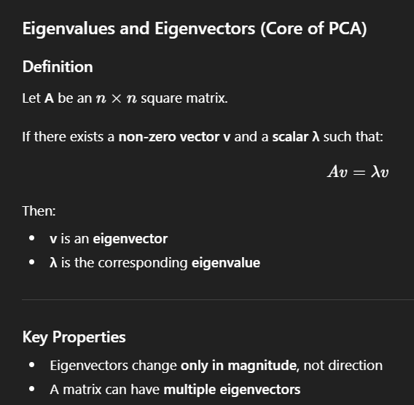
Eigenvalues and eigenvectors — the mathematical core of PCA (Av = λv)

Kernel PCA — non-linear
Uses a kernel function to implicitly map data into a higher-dimensional space where it becomes linearly separable, and applies PCA there — without ever explicitly computing the mapping (same kernel trick as SVM).

Tricky Interview Questions — Part 3
Q: Why does scaling matter for KNN but not for a decision tree?
KNN decides by distance: an unscaled feature with a big range (salary: 20,000–200,000) drowns out a small-range feature (age: 20–60), so neighbours are chosen by salary alone. A tree only asks threshold questions per feature ("age > 35?"); monotonic rescaling never changes which rows pass the threshold, so trees are scale-invariant.
Q: SMOTE before or after the train/test split?
Always AFTER the split, and only on the training set. If you SMOTE first, synthetic points generated from (future) test rows end up in training → leakage and inflated metrics.
Q: Why standardize before PCA?
PCA maximizes variance. Without standardization, a feature measured in big units (e.g., income in rupees) has artificially huge variance and hijacks the first principal component, regardless of its real importance.
Q: One-hot vs label encoding — when does label encoding silently hurt?
When applied to NOMINAL input features of linear or distance-based models: encoding Delhi=1, Mumbai=2, Pune=3 invents a fake order (Pune > Mumbai > Delhi) and fake distances. For tree models the damage is smaller (trees can split around it), and for the TARGET variable it is harmless because classes are just IDs.
Q: Both correlation filtering and PCA fight multicollinearity. What is the key difference?
Correlation filtering DROPS original features (keeps interpretability). PCA REPLACES them with combined components — multicollinearity disappears because components are orthogonal, but each component is a mix of all features and is harder to explain to stakeholders.

Part 4 — Supervised Learning: Linear Regression & Regularization

4.1 Linear Regression
Linear regression models the relationship between variables using a straight line with a constant slope. It determines the relationship between one dependent variable (Y) and one or more independent variables (X).
- OLS (Ordinary Least Squares): the core method used to estimate the coefficients — it finds the line that minimizes the sum of squared residuals.
- Loss function: Mean Squared Error. MSE = (1/n) × Σ(actual − predicted)².

Why divide by 2 in the cost function (but not in the metric)?
We don’t divide by 2 in the MSE metric, but we often do in the optimization cost function: when you take the derivative for gradient descent, the power 2 comes down and cancels with the 1/2 multiplier — the derivative becomes cleaner. It changes nothing about WHERE the minimum is.

4.2 Assumptions of Linear Regression
＋ Added concept: Your notes listed 3 assumptions. Interviewers usually expect 5 — Linearity and Independence of errors were missing and are added below.
- 1. Linearity (added): the relationship between X and Y is actually linear. Check with scatter/residual plots.
- 2. Normality of residuals: a residual is how far a point sits vertically from the regression line (+ or −). Normality means residuals are symmetric: most errors are near zero and large errors are rare.
- 3. Homoscedasticity: residuals have CONSTANT variance — the size of the errors does not grow or shrink as the predicted value changes. The model’s errors are stable across all levels of prediction.
- 4. No / little multicollinearity: independent variables should not be highly correlated with each other — correlated features explain the same information and make coefficients unstable.
- 5. Independence of errors (added): residuals should not be correlated with each other (no autocorrelation) — especially relevant for time-series data.
＋ Added concept: How to DETECT multicollinearity (often asked): correlation matrix for pairwise checks, and VIF (Variance Inflation Factor) for multi-feature checks — VIF > 5 (some use 10) signals a problem.

4.3 R² and Adjusted R²
- RSS (Residual Sum of Squares): Σ(actual − predicted)². Depends on the scale of the target; lower = better predictions.
- TSS (Total Sum of Squares): Σ(observed − mean of Y)² — total variation in the data.
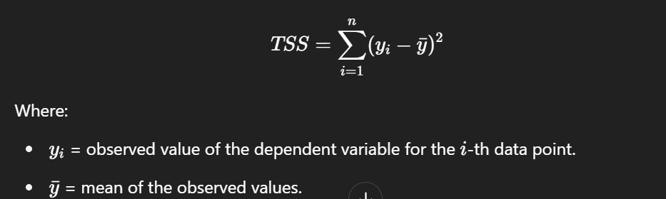
TSS — total variation of the observed values around their mean
R² (coefficient of determination) = (TSS − RSS) / TSS = Explained variation / Total variation. It answers: what percentage of the change in Y is explained by the X variables? R² = 1 is a perfect fit. There is no universal cut-off below which regression is "bad" — it depends on the domain.
✔ Correction: The note said "R² always lies between 0 and 1." That holds for the TRAINING data of a model with an intercept. On TEST data (or without intercept), R² can be NEGATIVE — it means the model predicts worse than simply always predicting the mean. A classic interview follow-up.

Problem with R² → Adjusted R²
- R² NEVER decreases when you add variables — even useless ones. It stays the same or increases, so it can’t tell you if a new feature genuinely helps.
- Adjusted R² accounts for the NUMBER of predictors: it punishes the model for extra useless features. Add a junk feature → adjusted R² goes DOWN. Range: −∞ to 1 (1 is best).
Example
Model with 5 real features: R² = 0.80, Adj-R² = 0.78. Add a column of random noise: R² = 0.801 (up!), Adj-R² = 0.77 (down — correctly signalling the new feature is useless).

4.4 Regularization: Ridge (L2) and Lasso (L1)
Regularization improves the model and prevents OVERFITTING by adding a penalty on coefficient size to the cost function. Ridge and Lasso are the simplest ways to reduce model complexity in linear regression. λ (lambda) is the shrinkage parameter controlling penalty strength; β₁...βp are the coefficients.

Ridge Regression — L2 (solves overfitting)
Cost = RSS + λ × Σ(βⱼ²) — penalty is the SQUARE of coefficient magnitudes. Shrinks coefficients toward zero (but never exactly zero) → reduces model complexity and helps with multicollinearity.
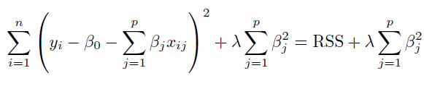
Ridge cost function: RSS + λ Σ βj²

Lasso Regression — L1 (feature selection)
Cost = RSS + λ × Σ|βⱼ| — penalty is the ABSOLUTE magnitude. L1 can push coefficients to EXACTLY zero, so features contributing little to Y are completely dropped → Lasso reduces overfitting AND performs feature selection.
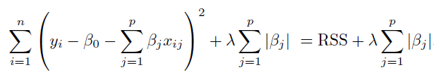
Lasso cost function: RSS + λ Σ |βj|
- Both Ridge and Lasso can absolutely be used with polynomial features.
Intuition example
10 features but only 3 truly matter. Ridge: all 10 coefficients become small (e.g., the useless ones ≈ 0.02) but stay in the model. Lasso: the 7 useless coefficients become exactly 0 — the model itself tells you which 3 features matter.

Tricky Interview Questions — Part 4
Q: Why does Lasso produce exactly-zero coefficients but Ridge doesn’t?
Geometric answer: the L1 constraint region is a diamond with sharp corners on the axes; the optimal solution often lands ON a corner, where some coefficients are exactly 0. The L2 region is a circle — smooth, no corners — so coefficients shrink but almost never hit exactly 0. Calculus answer: the L1 penalty’s gradient is constant (±λ) near zero, strong enough to push small coefficients all the way to 0; the L2 gradient (2λβ) fades as β→0.
Q: R² on the test set came out negative. Is the code broken?
No. Negative test-R² simply means the model is WORSE than predicting the mean of y for every row — a sign of severe overfitting or a meaningless model. R² is only guaranteed in [0,1] on training data with an intercept.
Q: When would you prefer Ridge over Lasso?
When most features genuinely contribute and/or features are highly correlated. With correlated features Lasso tends to arbitrarily pick one and zero out the rest, which is unstable; Ridge shares the weight among them. (Elastic Net combines both penalties to get the best of each.)
Q: Adding a feature increased R² — does that prove the feature is useful?
No. R² mathematically cannot decrease when features are added, even random noise. Check Adjusted R² (or cross-validated error): if it falls, the feature is hurting.

Part 5 — Classification Algorithms

5.1 Logistic Regression
Logistic Regression is a CLASSIFICATION algorithm, despite having "regression" in its name.
- Target: must be categorical.
- Features: assumes LOW multicollinearity — highly correlated features make the coefficients unstable to interpret, but do not "break" the model.
- How are β₀, β₁... estimated? NOT by OLS. Logistic regression uses Maximum Likelihood Estimation (MLE) — it finds the coefficients that make the observed labels most probable.
- Loss function: Log Loss / Binary Cross-Entropy.
- Regularization: L1 (Lasso) and L2 (Ridge) both available.
- Evaluation: confusion matrix (and the metrics built on it) — see Part 8.
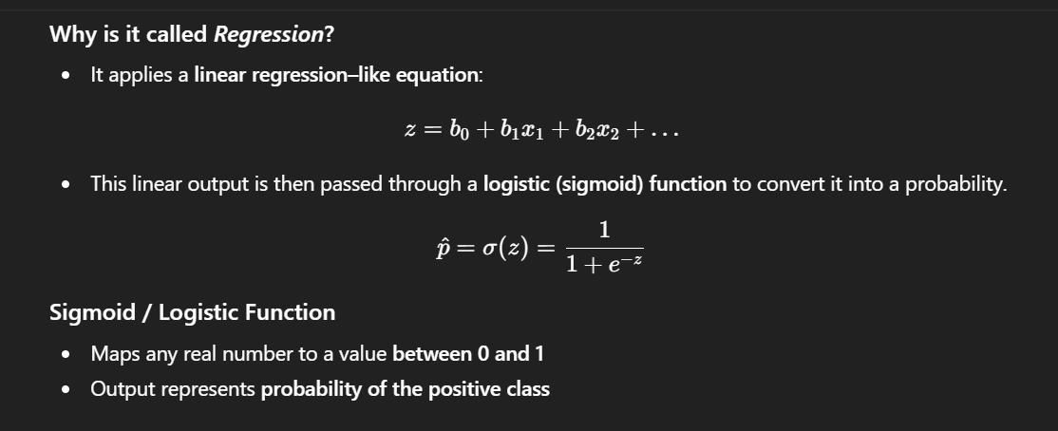
Why "regression"? A linear equation z = b0 + b1x1 + ... is passed through the sigmoid to become a probability between 0 and 1
Example
z = −2 + 0.05×(study hours). Student studies 60 hours → z = 1 → sigmoid(1) ≈ 0.73 → predicted probability of passing = 73% → class "Pass" (threshold 0.5).

5.2 K-Nearest Neighbours (KNN)
- Supervised; works for both classification and regression.
- Non-parametric and instance-based (lazy): NO training phase — all computation happens at prediction time.
- KNN does not learn any formula. With k = 3 it "simply checks the 3 nearest neighbours and answers based on them."

How it works
- 1. Choose K (number of neighbours). 2. Select a distance metric. 3. Compute distance from the test point to ALL training points. 4. Take the K nearest. 5. Predict: classification → majority vote; regression → average (or weighted average).
- There is no fixed rule for the best K (try several with cross-validation). Performance degrades in high dimensions (curse of dimensionality). Feature scaling is essential.
Example
New fruit: weight 160 g, redness 0.8. Its 3 nearest neighbours in the data are Apple, Apple, Cherry → predict Apple (2 votes vs 1).

5.3 Naive Bayes
A classification technique based on Bayes’ Theorem with the "naive" assumption that all features predicting the target are INDEPENDENT of each other. In real data features usually do depend on each other — Naive Bayes simply ignores this, and still works surprisingly well.
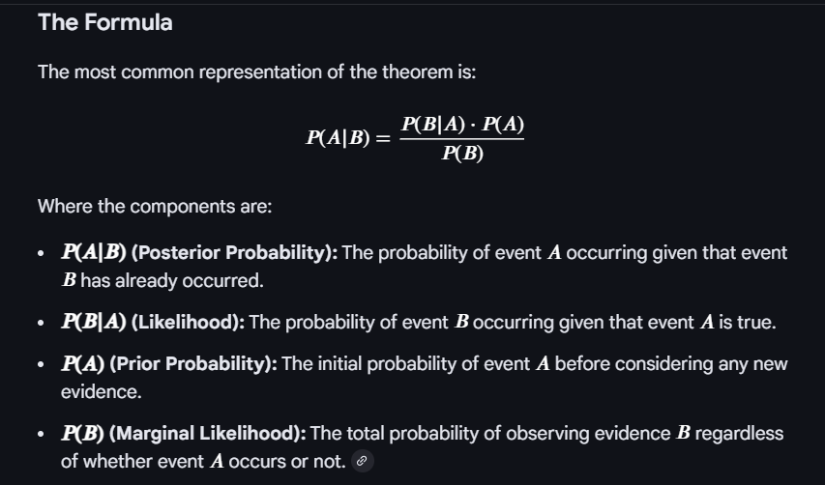
Bayes’ Theorem: posterior, likelihood, prior and marginal likelihood
Because of the conditional-independence assumption, the joint likelihood becomes a simple product of per-feature probabilities:

Naive independence: P(X|y) = P(x1|y) × P(x2|y) × ... × P(xn|y)
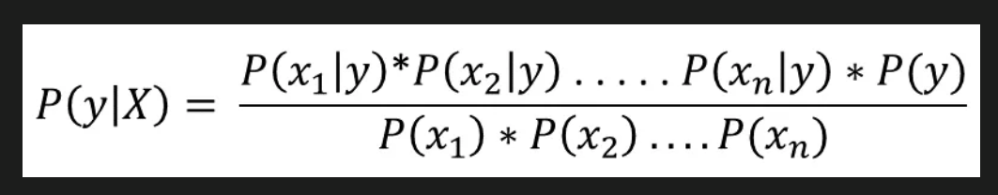
Putting it together: the posterior P(y|X) used for classification

Laplace (add-one) smoothing
Problem: probabilities are estimated from training frequencies. If a word never appeared with a class, its probability is 0 — and since everything is multiplied, ONE unseen word makes the whole product 0 and completely rejects the class.
Fix: add a small constant (usually 1) to every count in the numerator, and add the number of possible feature values (e.g., vocabulary size V) to the denominator → no probability is ever exactly zero.
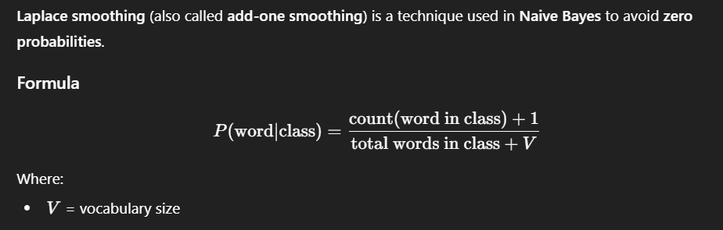
Laplace smoothing formula: (count + 1) / (total words in class + V)
Example
Spam classifier. Word "blockchain" never appeared in any ham email → P(blockchain|ham) = 0 → any email containing it could NEVER be ham. With smoothing: (0+1)/(10,000+50,000) — tiny, but not zero, so other words still get a say.

5.4 Support Vector Machines (SVM)
Supervised algorithm for classification and regression. Core idea: find the OPTIMAL hyperplane that best separates the classes in the labelled training data.
- Hyperplane: the decision boundary separating classes.
- Support vectors: the data points closest to the hyperplane — they alone define its position and orientation.
- Margin: the shortest distance between the hyperplane and the nearest support vectors. SVM maximizes this margin.

Linearly separable or not — the Kernel Trick
If a straight line/plane can separate the data, it is linearly separable. If not, we can project the data into a HIGHER-dimensional space where it may become separable. A kernel is a mathematical function that lets a linear classifier solve a non-linear problem by IMPLICITLY mapping data to that higher dimension — the points are never actually transformed. This computational shortcut is the "Kernel Trick". There is no universal rule for which kernel is best.
- Linear kernel: for linearly separable data; computationally efficient for large datasets.
- Polynomial kernel: uses polynomial combinations of features; higher degree → more complex boundaries.
- RBF (Radial Basis Function) kernel: measures SIMILARITY between two points: value 1 when X₁ = X₂, approaching 0 as distance grows. Gaussian in shape, controlled by the gamma parameter; behaviour resembles KNN. The most commonly used kernel in practice.
Example
Points on a 1-D line: class A at −2 and 2, class B at 0. No single threshold separates them. Map x → (x, x²): A becomes (−2,4),(2,4); B becomes (0,0). In 2-D a horizontal line at x² = 2 separates them perfectly — that is what a kernel does implicitly.

Hard margin vs Soft margin
- Hard margin: used when data is PERFECTLY linearly separable — zero tolerance for misclassification. Works only with no noise / no overlap.
- Soft margin: allows SOME controlled misclassification → more flexible and more robust to outliers and noise. The key difference is the tolerance for misclassification.

The C parameter (regularization)
- Small C: allows more misclassifications → wider margin, simpler model, less likely to overfit.
- Large C: punishes misclassifications heavily → narrow margin, can overfit.
- The penalty for a point grows the farther it lies on the WRONG side of the boundary.

5.5 Decision Trees
Supervised; works for both categorical and continuous targets. The primary goal: find the best splits that divide the data into the purest possible groups. Picking a random root will not solve the problem — the split must be chosen by a purity measure: Gini impurity, Information Gain (entropy) or Chi-square.
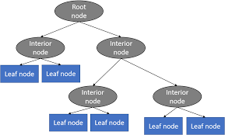
Structure of a decision tree: root, interior and leaf nodes
- Root node: the first node at the top.
- Leaf / terminal nodes: nodes where no further splitting happens.
- Pruning: cutting down nodes to stop overfitting.
What makes a split "good"?
Bad split — Left: 6 Pass / 5 Fail, Right: 5 Pass / 6 Fail → still mixed → useless.
Good split — Left: 10 Pass / 1 Fail, Right: 1 Pass / 10 Fail → very pure → informative.

Entropy
Entropy measures impurity. Entropy = 0 → the node is completely pure (one class only). For a BINARY target the maximum is 1, reached when the node is split 50–50.
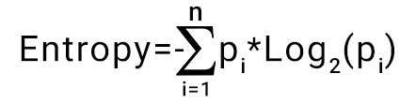
Entropy formula
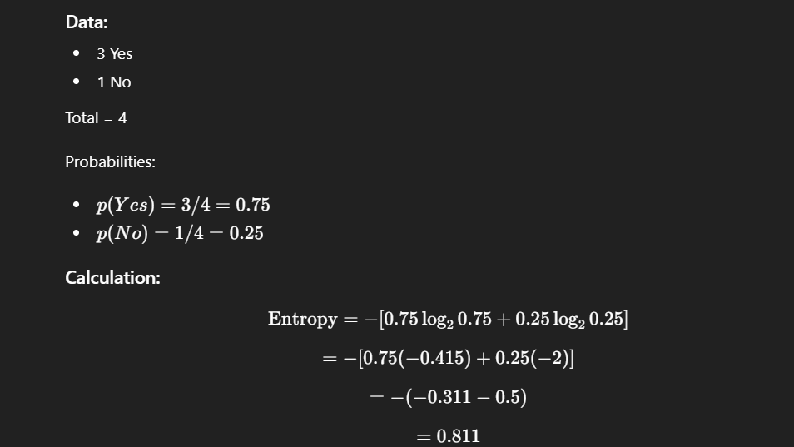
Worked entropy example: 3 Yes / 1 No → entropy = 0.811
✔ Correction: "Entropy ranges between 0 and 1" is only true for BINARY classification. With k classes the maximum is log₂(k) — e.g., 3 equally likely classes give entropy ≈ 1.585. Gini’s "0 to 0.5" range is likewise binary-only (general max = 1 − 1/k).

Gini impurity
Same purpose as entropy — measuring split purity. A pure node has Gini = 0; for binary targets the maximum is 0.5. Gini is usually preferred because it is easier/faster to compute (no logarithm). Note: these impurity measures apply to classification; for continuous targets, regression trees use variance/MSE reduction instead.
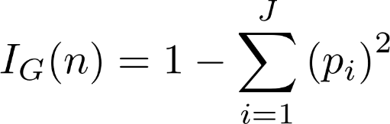
Gini impurity formula

Information Gain
IG = Entropy(parent) − weighted Entropy(children). The more the entropy drops after a split, the more information was gained. The feature with the HIGHEST information gain is selected for the split. Information gain cannot exist without a split.

Hyperparameters
- max_depth — maximum depth of the tree.
- min_samples_split — minimum samples required to split an internal node.
- min_samples_leaf — minimum samples required at a leaf node.
- max_features — number of features considered when looking for the best split.

Pre-pruning vs Post-pruning
- Pre-pruning: restrict the tree BEFORE/WHILE building it (max_depth, min_samples_split) to prevent overfitting.
- Post-pruning (backward pruning): grow the full (deep, overfitted) tree first, then cut branches back — in sklearn via cost-complexity pruning (ccp_alpha).
- Main weakness of a single tree: a small change in training data can produce a completely different tree (high variance) — the motivation for Random Forest.

5.6 Random Forest
Supervised algorithm for classification and regression. A Random Forest is a collection of decision trees trained in a special way: a single decision tree builds ONE tree using ALL data and ALL features; a random forest builds MANY trees, each using random data and random features. Two sources of randomness:
- (1) Bootstrapping (data randomness): each tree trains on a bootstrap sample — random sampling WITH replacement, same size as the original dataset. Some rows appear multiple times, some not at all.
- (2) Feature randomness (split randomness): at each split the tree considers only a RANDOM SUBSET of features, not all of them — this de-correlates the trees.

Bootstrapping & Bagging
- Bootstrapping: a resampling technique — create multiple new datasets from the original by sampling with replacement.
- Bootstrap Aggregation = Bagging: train multiple models on bootstrap samples and combine (average/vote) their predictions — used to estimate performance and to reduce overfitting.

Parameters
- n_estimators — number of trees built before averaging predictions.
- max_features — max features considered when splitting a node.
- min_samples_leaf — minimum samples at a leaf.
- oob_score — "out-of-bag" evaluation: roughly one-third of rows are NOT in a given tree’s bootstrap sample; those out-of-bag rows act as a built-in validation set, giving cross-validation-like evaluation for free.

Tricky Interview Questions — Part 5
Q: Why does logistic regression use MLE instead of OLS?
Squared error on sigmoid outputs gives a NON-convex cost with many local minima, and OLS’s assumptions (normal, constant-variance errors) don’t hold for 0/1 outcomes. Maximizing likelihood (equivalently minimizing log loss) gives a convex problem with one global minimum that gradient descent reliably finds.
Q: Naive Bayes’ independence assumption is almost always false. Why does it still work?
For classification we only need the CORRECT CLASS to get the highest score — the probability values themselves can be badly miscalibrated. The ranking of classes often survives violated independence, especially in high-dimensional sparse data like text.
Q: Why does Random Forest need feature randomness when bagging already randomizes the data?
With bootstrapping alone, every tree would still grab the same few dominant features at the top, making the trees highly CORRELATED — and averaging correlated trees barely reduces variance. Random feature subsets force trees to be different, and averaging de-correlated trees is what actually cuts variance.
Q: Gini vs Entropy — does the choice matter?
In practice they produce very similar trees. Gini is preferred mainly because it avoids computing logarithms (faster). Entropy slightly favours more balanced splits. It is rarely the reason a model performs differently.
Q: In KNN, what happens if K is too small or too large?
K too small (e.g., 1): the prediction follows individual noisy points → overfitting (high variance). K too large: neighbourhoods include points of other classes and everything drifts toward the majority class → underfitting (high bias). K is a bias–variance dial; tune it with cross-validation and prefer odd K for binary problems to avoid ties.
Q: What do the support vectors actually do? What if we delete other points?
Only the support vectors (the points touching/violating the margin) define the hyperplane. Deleting any NON-support-vector point changes nothing — retraining gives the same boundary. That is why SVMs can be memory-efficient at prediction time.

Part 6 — Ensemble Methods
Ensemble methods create multiple models and combine them to produce improved results — usually more accurate than any single model. Used for both regression and classification.
Type | How models learn | Mainly reduces | Example
Bagging | In PARALLEL on bootstrap samples | Variance (overfitting) | Random Forest
Boosting | SEQUENTIALLY, each fixing previous errors | Bias (underfitting) | AdaBoost, GBM, XGBoost
Stacking | Heterogeneous models + meta-learner | Both (via combination) | KNN + LogReg + SVM → meta-model

6.1 Bagging (Bootstrap Aggregation)
Train many models on different bootstrap samples (random sampling with replacement) and combine their predictions (vote/average). It reduces overfitting. Random Forest is the classic example. Bagging is not limited to trees — e.g., bagging many KNN models on different data subsets smooths the decision boundary and makes it more robust to noise without increasing k.

6.2 Boosting
Models are built one after another; each new model tries to correct the errors of the previous ones. Models keep being added until the training data is predicted well enough or the maximum number of models is reached.

AdaBoost (Adaptive Boosting)
- Creates many WEAK learners — usually decision stumps (trees with a single split, depth = 1). The number of stumps is user-defined.
- Initially all observations get EQUAL weights. A stump is trained; it automatically picks the feature + threshold that minimizes the weighted error.
- Weight update: misclassified observations → weight INCREASED; correctly classified → weight DECREASED; then all weights are normalized to sum to 1.
- Because hard observations now weigh more, the NEXT stump focuses on them. Repeat sequentially until the chosen number of stumps is built or error ≥ 0.5.
- Each stump picks one feature and one threshold; across rounds, different features can be selected, and a feature can be reused.
Example
Round 1 stump misclassifies 10 fraud cases → their weights rise. Round 2 stump is now "paid more" to get exactly those 10 right, so it picks a split that handles them — the ensemble gradually covers the hard cases.

Gradient Boosting
- Learning happens by optimizing a LOSS function. Builds larger trees than AdaBoost (typically depth 3–8, not stumps).
- Mechanism: compute residual errors (actual − predicted); train the next tree to predict those residuals; scale the new tree’s output by a learning rate; add it to the ensemble. Repeat until a stopping criterion (fixed number of trees, or minimal loss improvement).
- Each new tree faces smaller and smaller residuals, so the total prediction converges toward the actual values.
Worked example
Actual house price = 100. Initial guess (mean) = 70 → residual 30.
Tree 1 predicts the residual ≈ 30; with learning rate 0.1 → prediction = 70 + 0.1×30 = 73 → new residual 27.
Tree 2 learns 27 → prediction = 73 + 2.7 = 75.7 ... hundreds of small corrections later, prediction ≈ 100.
Final prediction = initial guess + LR×Tree1 + LR×Tree2 + ... + LR×TreeN.

XGBoost
An optimized, regularized, engineered version of Gradient Boosting built for speed, accuracy and scalability. Key differences from plain GBM:
- Uses first-order AND second-order derivatives (gradient + Hessian); plain GBM uses only first-order residuals.
- Built-in regularization; post-pruning (bottom-up), whereas pruning in plain GBM is minimal/absent.
- Handles missing values automatically; supports custom loss functions and early stopping.
- Parallelism — common confusion: XGBoost does NOT build multiple trees in parallel (boosting is inherently sequential). The parallel computation happens INSIDE a single tree — evaluating candidate splits across features simultaneously.

6.3 Stacking
Stacking combines HETEROGENEOUS models (different algorithms — e.g., KNN, Logistic Regression, SVM). Each base model trains on the same dataset but learns patterns in its own way. Their output predictions are then used as INPUT FEATURES for another model — the meta-model (meta-learner) — which learns how to optimally combine them into the final output.
- So stacking has at least TWO levels. More levels are possible but do not guarantee better performance.
- Leakage guard: the meta-model is trained on OUT-OF-FOLD predictions of the base models (each base model predicts rows it was not trained on), otherwise the meta-model would learn from memorized answers.
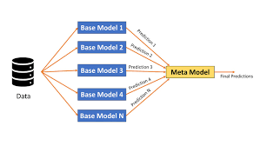
Stacking: base models’ predictions become the meta-model’s input features

Tricky Interview Questions — Part 6
Q: Why does bagging reduce variance while boosting reduces bias?
Bagging averages many INDEPENDENT-ish overfitted models — random errors cancel out, so the ensemble is more stable (variance ↓). Boosting chains many WEAK (high-bias) models, each correcting what the previous ones missed, steadily increasing the ensemble’s expressive power (bias ↓). That is also why boosting CAN overfit if you add too many rounds, while bagging rarely does.
Q: "XGBoost is fast because it builds trees in parallel" — true or false?
False, and a very common trap. Boosting is sequential by definition (tree N needs the errors left by trees 1...N−1). XGBoost’s parallelism is WITHIN each tree: candidate splits over features/bins are evaluated in parallel.
Q: Why use a small learning rate plus many trees in gradient boosting?
Each tree then makes only a tiny correction, so no single tree can overfit the residual noise; many small steps generalize better than few big ones. Trade-off: more trees = more training time. Learning rate and n_estimators are tuned together.
Q: In stacking, why out-of-fold predictions for the meta-model?
If a base model predicts the same rows it trained on, those predictions are unrealistically accurate (memorized). The meta-model would learn to over-trust that base model and fail on new data. Out-of-fold predictions reflect honest, generalization-level performance.

Part 7 — Gradient Descent & Loss Functions

7.1 Gradient Descent
Gradient Descent is an optimization algorithm used to MINIMIZE a cost (loss) function. In simple words: we stand on the slope of the cost surface and keep stepping downhill until we reach the lowest point (the global minimum). A convex function has exactly one global minimum and no local minima — which is why convex losses are loved.
- Slope pointing to the right is positive (and vice versa). The NEGATIVE gradient always points downhill fastest, so we move opposite to the slope.
- The slope is computed using partial derivatives of the cost with respect to each parameter (m = weight/slope of the hypothesis, b = bias/intercept).
- Update rule: new parameter = old parameter − (learning rate × gradient).
- Learning rate α: too LARGE → may overshoot and bounce past the minimum; too SMALL → painfully slow convergence.
- Near a minimum the derivative becomes smaller, so the steps automatically become smaller too — the algorithm naturally slows down as it closes in.
- Stop when the gradient is close to zero or after a fixed number of iterations.
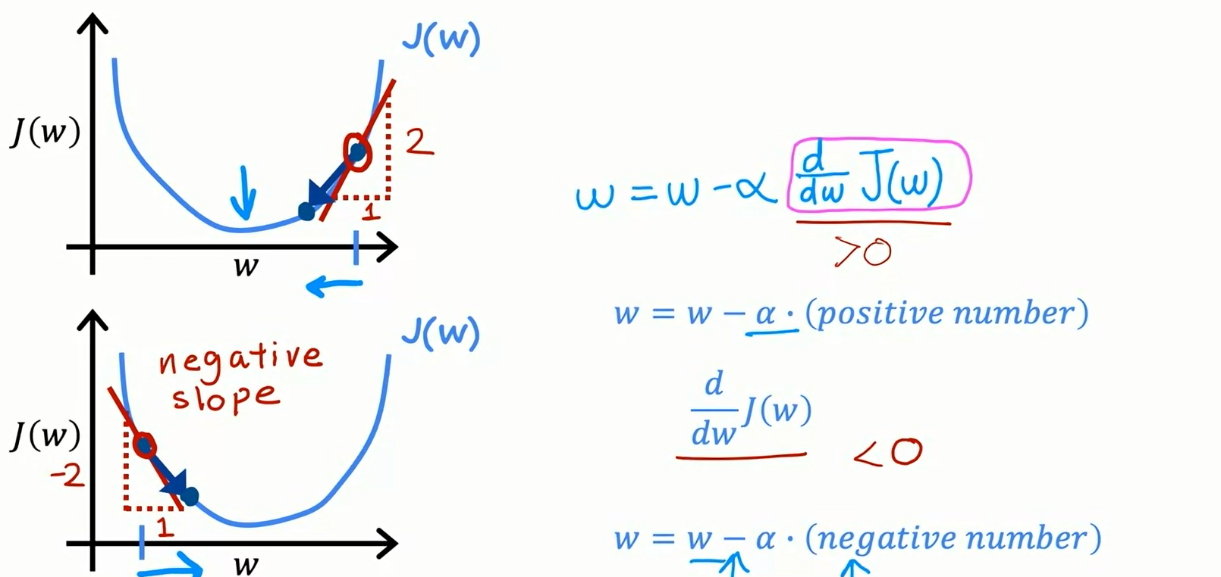
Positive vs negative slope: the sign of the gradient decides the direction of the step
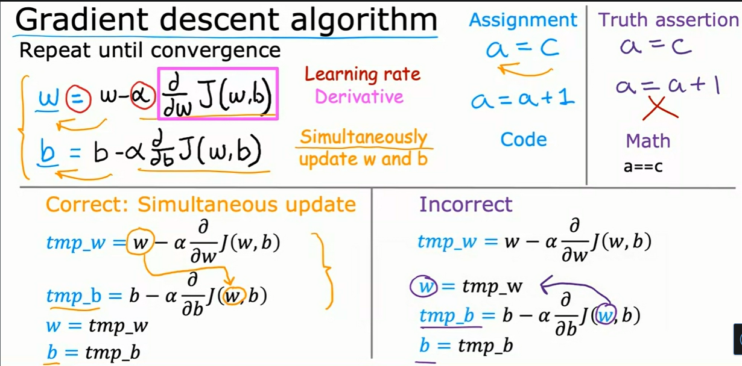
The gradient descent algorithm: simultaneously update w and b until convergence
For a simple linear model with two parameters (w and b), the cost surface looks like a bowl. Gradient descent rolls down this bowl to the bottom.
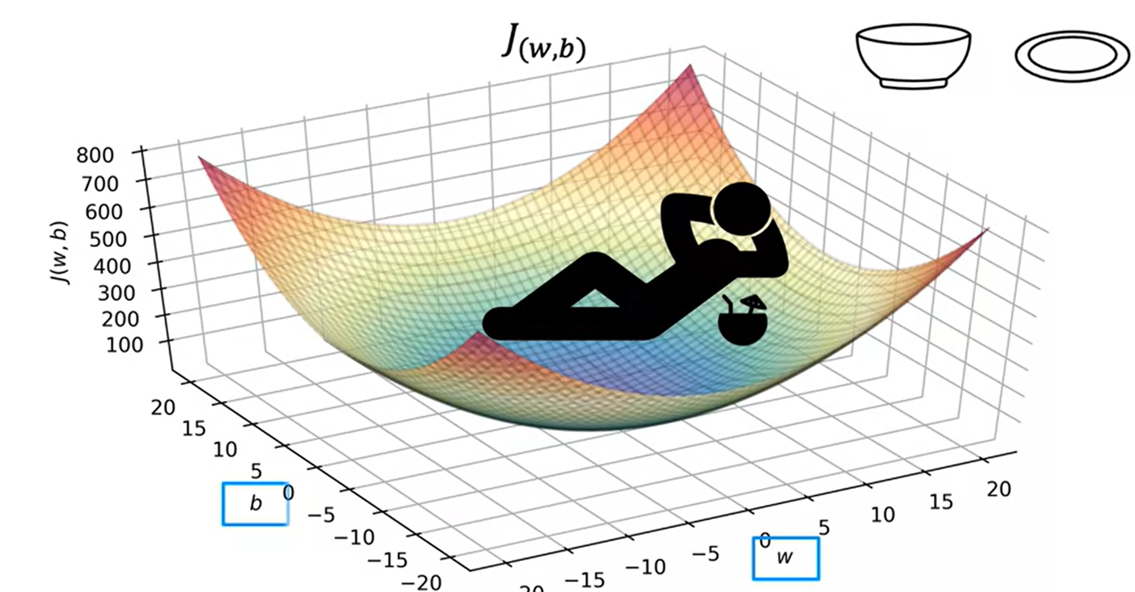
The bowl-shaped (convex) cost surface for a 2-parameter model — one global minimum
Example
Cost = (w − 5)². Start w = 1, α = 0.1. Gradient = 2(w−5) = −8 → w = 1 − 0.1×(−8) = 1.8 → next gradient −6.4 → w = 2.44 ... each step moves toward w = 5, in shrinking steps as the slope flattens.

Why feature scaling speeds up gradient descent
Scaling the inputs (mean normalization or z-score) gives the error surface a more SPHERICAL (circular) shape. Without scaling it is a long, narrow, high-curvature ellipse, and the gradient zig-zags across the valley taking many steps that are not in the optimal direction.
- When the surface is circular, the gradient points straight at the minimum → learning is fast and direct.
- When the surface is a stretched ellipse, each step overshoots sideways → many wasted, oscillating steps.
＋ Added concept: This is the same reason distance-based and gradient-based models need scaling (see 3.3): the optimizer literally takes a more efficient path on a well-scaled surface.

Variants by how much data each step uses
- Batch GD: uses the WHOLE dataset for every update — accurate gradient, but slow and memory-heavy.
- Stochastic GD (SGD): uses ONE randomly picked sample per update. Fast and noisy.
- Mini-batch GD: uses a small random batch per update — the practical middle ground (e.g., 32, 64, 128 samples).

Local minima & saddle points — and how to escape
A local minimum is the lowest point in a small neighbourhood but not overall; a saddle point has zero gradient yet is neither a minimum nor a maximum. Getting stuck in either means sub-optimal performance.
- Randomness (from SGD/mini-batch): the loss landscape for the next randomly sampled point is slightly different, so even if we are stuck for one sample, the jolting movement of the next sample shakes us out and lets us keep moving toward a better minimum.

Optimizers — making gradient descent smarter
The plain update rule can be slow or get stuck. These optimizers improve it, each building on the previous one.
1. SGD with Momentum.
Momentum gives the algorithm "memory" of its past direction using an Exponential Moving Average (EMA) — a moving average that weights recent gradients more heavily. Intuition: if I keep being told to move in the same direction, I gain confidence and take bigger steps that way. The current update depends on the present gradient PLUS the accumulated past gradients (scaled by a factor, often called gamma or alpha).
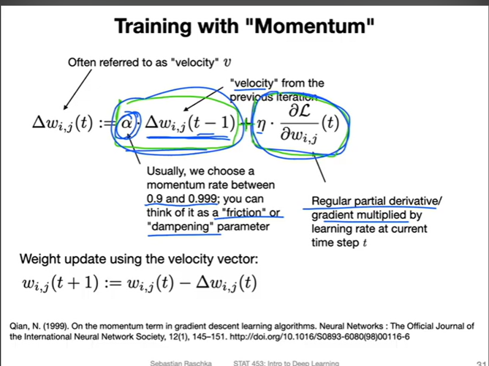
Training with momentum: the update keeps a "velocity" from the previous step plus the current gradient
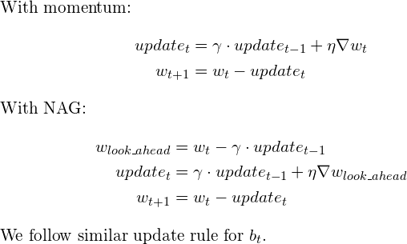
Momentum update rule (top) vs Nesterov update rule (bottom)
- Trade-off: moving fast is not always good. Momentum can OVERSHOOT and oscillate in and out of the minimum valley (taking several U-turns) before settling. Despite the U-turns, it still converges FASTER than vanilla gradient descent.
2. Nesterov Accelerated Gradient (NAG).
A smarter momentum: first compute a "look-ahead" position using the existing velocity, then measure the gradient THERE, and use that to make the real update. Because it looks ahead before stepping, it still overshoots but by a SMALLER amount — shorter U-turns and less oscillation than plain momentum.
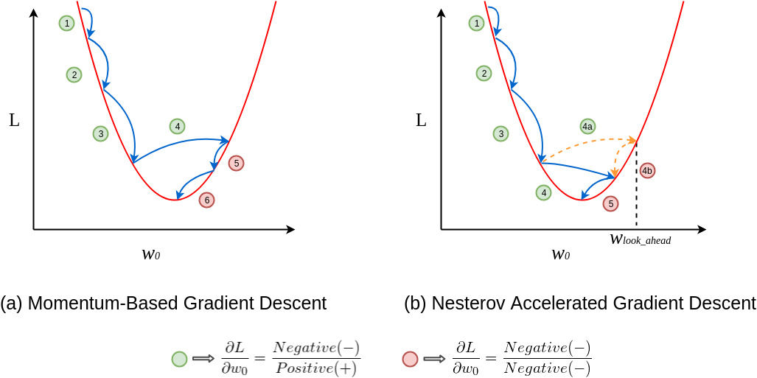
(a) Momentum-based vs (b) Nesterov: NAG takes shorter U-turns around the minimum
3. Adagrad (Adaptive Gradient).
Uses a DIFFERENT learning rate for each parameter, automatically — no manual tuning of the rate. It divides the learning rate by the square root of the sum of all past squared gradients for that parameter.
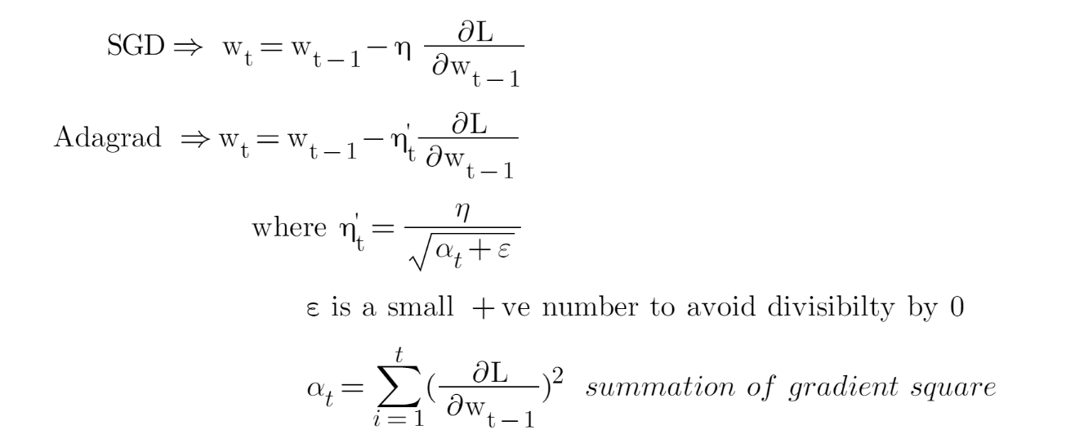
SGD vs Adagrad: Adagrad divides the step by the accumulated sum of squared gradients
- Downside: the denominator (sum of squared gradients) only ever GROWS, so the learning rate keeps shrinking monotonically and can become so tiny that the model stops learning altogether.
4. RMSProp (Root Mean Square Propagation).
Fixes Adagrad’s vanishing learning rate. Instead of summing ALL past squared gradients, it keeps a MOVING AVERAGE of recent squared gradients, so old gradients fade away and the learning rate does not collapse to zero.
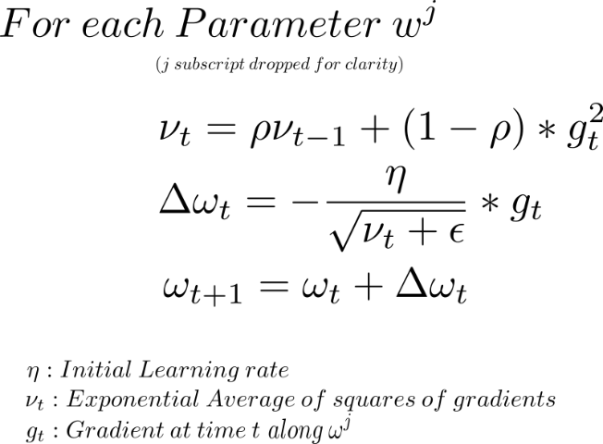
RMSProp update: divide the gradient by the root of a moving average of squared gradients
- Note: the learning rate still has to be set manually, and the suggested default does not work for every problem.
5. Adam (Adaptive Moment Estimation).
The most popular optimizer. It combines the ideas of Momentum (a moving average of past gradients — the "first moment") and RMSProp (a moving average of past squared gradients — the "second moment"), and adds a bias-correction step so the early estimates are not skewed toward zero.
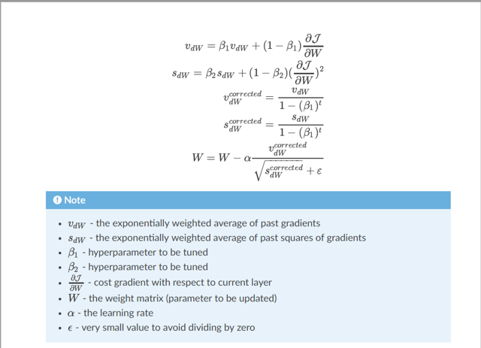
Adam update rule: first moment (v), second moment (s), bias correction, then the parameter step
How to remember the family
Momentum = remember the DIRECTION you were going.
RMSProp = remember how BIG recent gradients were, per parameter.
Adam = remember BOTH (direction + size) → fast, robust default.

Quick comparison of common optimizers — memory cost, strengths, and weaknesses:
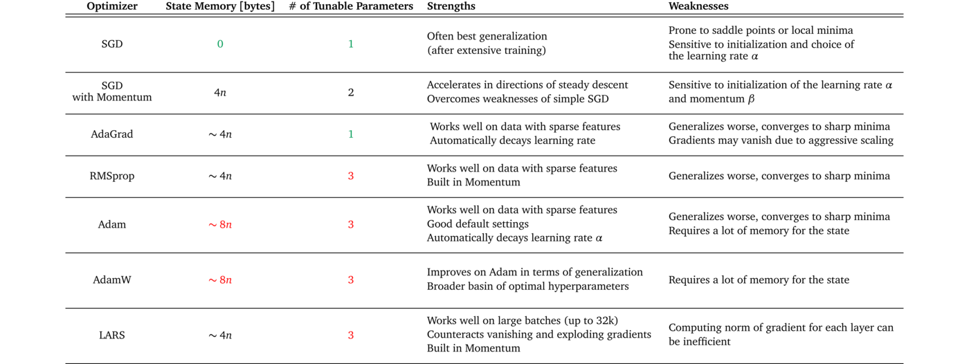
Optimizer comparison: state memory, tunable parameters, strengths, weaknesses

7.2 Regression Loss Functions

1. MSE — Mean Squared Error
Mean of squared differences between actual and predicted. Being quadratic it has a single global minimum. Squaring punishes BIG errors heavily — use MSE when large errors are especially undesirable. Downside: very sensitive to outliers.

2. RMSE — Root Mean Squared Error
Square root of MSE. Still penalizes large errors, but less explosively than raw MSE, and is in the same units as the target (easier to interpret).

3. RMSLE — Root Mean Squared Logarithmic Error
Like RMSE but log is applied BEFORE taking the difference. With RMSE one extreme outlier can explode the error; with RMSLE outliers are drastically scaled down — introducing an outlier barely moves the score.
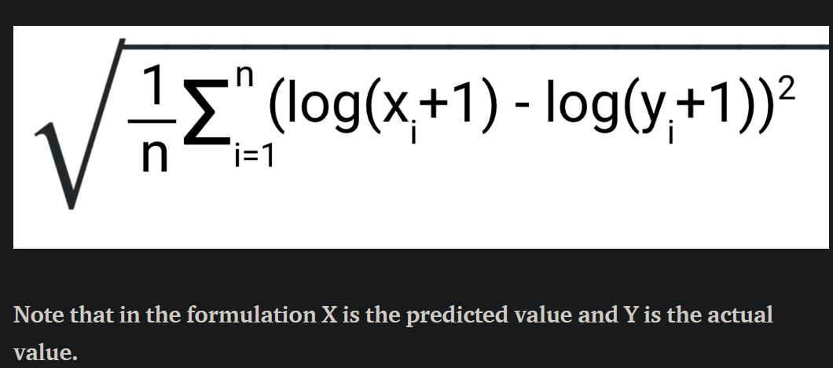
RMSLE formula (here X = predicted, Y = actual)
Because log(a) − log(b) = log(a/b), RMSLE actually measures the RATIO of predicted to actual, i.e. relative error:
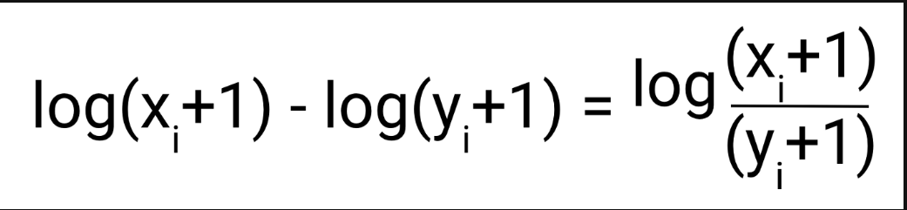
The log-difference equals the log of the ratio — RMSLE cares about relative error
- Asymmetry: more penalty when the prediction is LESS than the actual (under-prediction) and less penalty for over-prediction — useful e.g. in demand forecasting where under-stocking is worse.
Example
Actual 100 → predicted 110 vs actual 10,000 → predicted 11,000: RMSE treats the second error (1,000) as 100× worse; RMSLE treats them as EQUAL (both off by 10%).

4. MAE — Mean Absolute Error
Mean of absolute differences. Never negative. Treats every unit of error equally (no squaring), so it is robust to outliers.
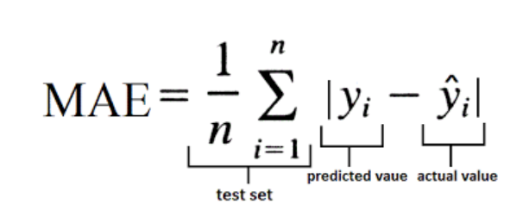
MAE formula

5. Huber Loss
The best of both worlds: for errors smaller than a threshold delta it behaves like MSE (quadratic); for errors larger than delta it switches to MAE-like (linear). Use it when you want outliers to have SOME weight, but not too much. One parameter: delta.
Loss | Outlier sensitivity | When to use
MSE | Very high | Large errors are unacceptable; clean data
RMSE | High | Like MSE but interpretable units
MAE | Low | Outliers present; all errors equal
RMSLE | Very low | Relative error matters; under-prediction worse
Huber | Tunable (delta) | Balance between MSE and MAE

7.3 Classification Loss Functions

Binary Cross-Entropy / Log Loss
Built on the fact that log(1) = 0. It compares each predicted probability (any value between 0 and 1) with the actual class (0 or 1), and penalizes the probability based on its DISTANCE from the true value. pᵢ = predicted probability of class 1; (1−pᵢ) = probability of class 0. Confident wrong predictions are punished brutally (−log of a tiny number is huge).
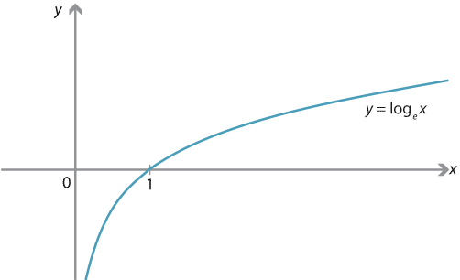
The log curve — the engine behind log loss: log(1)=0, log(x)→−∞ as x→0
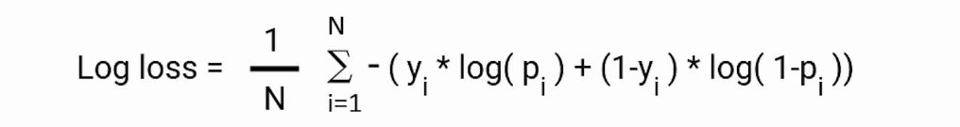
Binary log loss formula
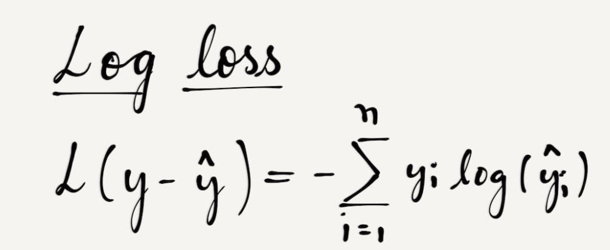
Log loss in compact form
Example
True class = 1. Predict 0.9 → loss = −log(0.9) ≈ 0.105 (small). Predict 0.1 → loss = −log(0.1) ≈ 2.303 (huge). Confidently wrong costs ~22× more than confidently right.

Weighted Cross-Entropy
Adds a scaling parameter alpha to BCE so one error type can be penalized more harshly — typically alpha multiplies the positive-class term.
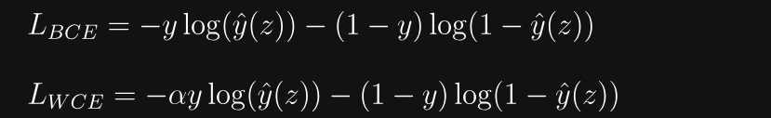
Binary Cross-Entropy (top) and Weighted Cross-Entropy (bottom) — alpha scales one of the terms
✔ Correction: The original note had the direction reversed. With the standard formulation (alpha on the positive term): alpha > 1 punishes FALSE NEGATIVES more (missing a positive becomes more expensive — use for fraud/cancer detection); alpha < 1 effectively punishes FALSE POSITIVES relatively more. Always state which term alpha multiplies — that determines the direction.

Hinge Loss (mostly used in SVM)
Hinge loss is the loss behind Support Vector Machines. SVM treats the two classes as +1 and −1 (if your labels are 0/1 you must first map them to −1/+1). The classifier outputs a real number (e.g., 2, 2.5, −1.2) whose SIGN says which side of the boundary the point is on, and whose MAGNITUDE says how far.
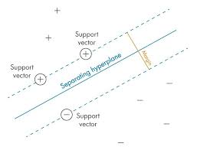
SVM terms: hyperplane (decision boundary), margin, and the support vectors nearest to it
- Formula: l(y) = max(0, 1 − t·y), where t is the true label (+1 or −1) and y is the classifier output.
- Correct AND beyond the margin (distance > margin) → loss = 0, no penalty.
- Correct but INSIDE the margin → small penalty between 0 and 1.
- On the WRONG side of the boundary → loss > 1, growing linearly with distance.
Example
True = +1, output = 0.5 → l = max(0, 1 − 1·0.5) = 0.5 (correct but inside margin → small penalty).
True = −1, output = 0.5 → l = max(0, 1 − (−1)·0.5) = 1.5 (misclassified → larger penalty).

＋ Added concept: Unlike linear regression, which MINIMIZES distance from the points, SVM MAXIMIZES the distance (margin) from the nearest points — hinge loss is what encodes that goal.

Categorical Cross-Entropy (multi-class)
Binary cross-entropy expanded to multiple classes. Requirement: labels must be ONE-HOT encoded — then only one element of the sum is non-zero (everything else is multiplied by 0).
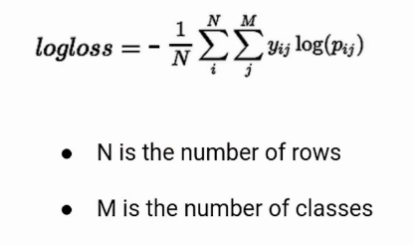
Multi-class log loss: N rows, M classes
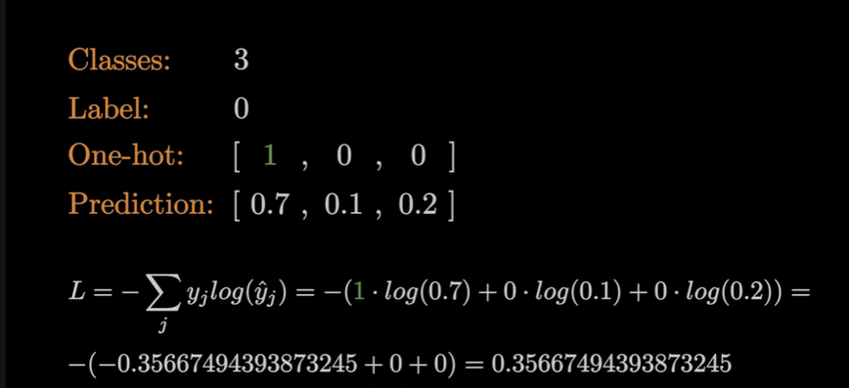
Worked example: one-hot label [1,0,0], prediction [0.7,0.1,0.2] → loss = −log(0.7) ≈ 0.357

Sparse Categorical Cross-Entropy
Mathematically the SAME loss — but targets are provided as plain integers (e.g., 3, 1, 2) instead of one-hot vectors. Saves memory and computation when there are many classes, because each label is a single integer rather than a whole vector.

Kullback–Leibler (KL) Divergence Loss
KL divergence measures how well one probability distribution MATCHES another. It is the gap between the model’s predicted distribution and the true distribution.
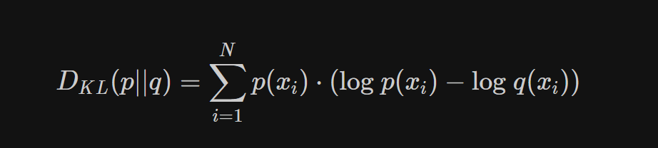
KL divergence formula — measures the mismatch between two distributions p and q
- KL = 0 means the two distributions are identical (no difference at all).
- The larger the KL value, the more the predicted distribution differs from the true one.
＋ Added concept: KL divergence is closely related to cross-entropy: minimizing cross-entropy is equivalent to minimizing KL divergence between the true and predicted label distributions. It is also used in areas like variational autoencoders and knowledge distillation.

Multi-label loss: Hamming Loss
Hamming Loss = (number of wrong label predictions) / (total label predictions) — averaged over all labels. It is used when each sample can have MANY labels at once (multi-label), counting both wrong predictions and missed labels. Ideally Hamming loss is 0; the smaller, the better.
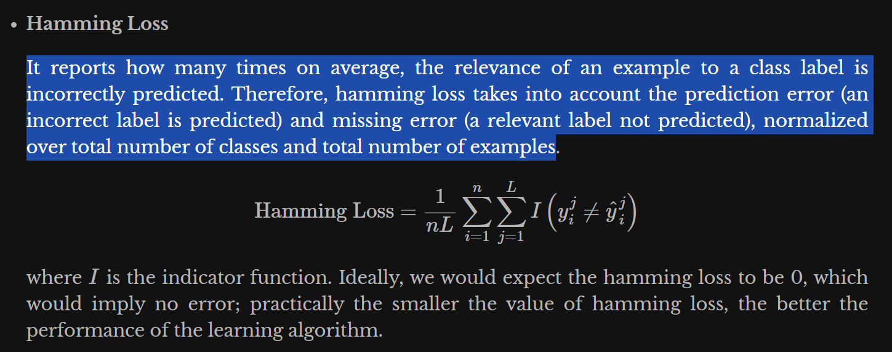
Hamming Loss formula: fraction of individual label predictions that are wrong
Example
Labels [Dog, Cat, Bird, Horse]; truth y = [1,0,1,0]; prediction ŷ = [1,1,0,0]. Wrong on Cat and Bird → 2/4 = 0.5.

Tricky Interview Questions — Part 7
Q: Why not just use accuracy as the training loss for classification?
Accuracy is a step function — flat almost everywhere, so its gradient is zero and gradient descent has no direction to follow. Log loss is smooth and differentiable, and it rewards CALIBRATED probabilities, not just correct labels.
Q: Why does feature scaling speed up gradient descent?
With unscaled features the cost surface is a long, narrow valley (elongated ellipses); the gradient zig-zags across the valley instead of going down it. Scaling makes the contours roughly circular, so the gradient points almost straight at the minimum → far fewer iterations.
Q: Model A predicts 0.51 and model B predicts 0.99 for true positives. Same accuracy — same log loss?
No. Both are "correct" at threshold 0.5, so accuracy is identical, but log loss strongly prefers B: −log(0.99) ≈ 0.01 vs −log(0.51) ≈ 0.67. Log loss measures CONFIDENCE quality, which accuracy cannot see.
Q: Categorical vs sparse-categorical cross-entropy — when does the choice actually matter?
The math is identical; only the LABEL FORMAT differs (one-hot vs integer). With 10,000 classes, one-hot labels are 10,000-long vectors per row — sparse saves huge memory and is faster. One-hot form is needed mainly for soft labels (e.g., label smoothing).
Q: Why does SGD sometimes generalize better than full-batch gradient descent?
The noise in stochastic updates acts like a built-in explorer: it can shake the parameters out of sharp, narrow minima (which usually generalize poorly) and settle them into flatter minima (which generalize better) — apart from also being far cheaper per update.
Q: Adagrad vs RMSProp — what exactly did RMSProp fix?
Adagrad divides the step by the SUM of all past squared gradients, and that sum only grows, so the learning rate keeps shrinking until learning effectively stops. RMSProp replaces the running SUM with a moving AVERAGE of recent squared gradients, so old gradients decay away and the learning rate stays usable.
Q: What two ideas does Adam combine, and why the bias correction?
Adam combines Momentum (a moving average of gradients = the first moment, giving direction) with RMSProp (a moving average of squared gradients = the second moment, giving a per-parameter scale). Both averages start at zero, so early on they are biased toward zero; the bias-correction step rescales them so the first few updates are not artificially tiny.
Q: Momentum vs Nesterov — what is the practical difference?
Plain momentum measures the gradient at the CURRENT position and then adds velocity, so it tends to overshoot the valley and take big U-turns. Nesterov first jumps to a LOOK-AHEAD position using the velocity, measures the gradient there, and corrects — so it anticipates the overshoot and takes shorter U-turns, converging more smoothly.
Q: Hinge loss vs log loss — when does each make sense?
Hinge loss (SVM) cares only about the MARGIN: once a point is correct and beyond the margin, its loss is exactly 0 — it stops caring. Log loss (logistic/softmax) never reaches 0; it keeps pushing for more confident, well-CALIBRATED probabilities. Use hinge when you only need the decision boundary; use log loss when you need probability estimates.

Part 8 — Model Evaluation: Classification Metrics
Accuracy is generally reliable on BALANCED datasets and misleading on imbalanced ones — which is why everything below exists.

8.1 Confusion Matrix
Can be built for binary, multi-class and multi-label problems (NOT for regression). Most valuable on imbalanced data, but still useful on balanced data because it gives a detailed breakdown of error types.
- TP: predicted Positive, actually Positive. TN: predicted Negative, actually Negative.
- FP (Type I error): predicted Positive, actually Negative — a false alarm.
- FN (Type II error): predicted Negative, actually Positive — a miss.
Example (1,000 patients, 50 sick)
Model flags 60 as sick: 45 truly sick (TP), 15 healthy flagged (FP), 5 sick missed (FN), 935 correct healthy (TN). Accuracy = 98% — but it missed 10% of the sick patients.

8.2 Precision, Recall and the Trade-off
- Precision (quality): out of everything the model CLAIMED positive, how many really were? TP / (TP + FP).
- Recall / Sensitivity (quantity): out of everything ACTUALLY positive, how many did the model catch? TP / (TP + FN).
- Trade-off: increasing recall usually decreases precision and vice-versa (lowering the threshold catches more positives but raises false alarms).
From the example above
Precision = 45/60 = 0.75 (75% of "sick" calls were right). Recall = 45/50 = 0.90 (caught 90% of the sick).

8.3 F1, Macro-F1 and F-beta
We don’t want to carry both precision AND recall around — so F1 combines them: F1 = 2 × (Precision × Recall) / (Precision + Recall). Range 0 (cannot classify anything correctly) to 1 (perfect). An F1 score exists per class.
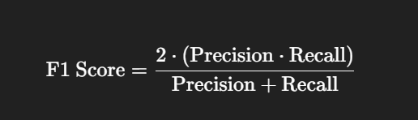
F1 score — the harmonic mean of precision and recall
- Why HARMONIC mean? use the harmonic mean when a SMALL value should pull the average down. If either precision or recall is tiny, F1 becomes tiny — arithmetic mean would hide the weakness (P=1.0, R=0.0 → arithmetic 0.5, harmonic 0).
- Macro-F1: the simple arithmetic average of all per-class F1 scores — treats every class equally, so it reflects performance across the whole dataset including small classes.

F-beta score
Generalizes F1 with a knob β: β = 1 → precision and recall matter equally (F1); β < 1 → precision matters more; β > 1 → recall matters more. Memory trick: P comes before R, so β < 1 = Precision priority, β > 1 = Recall priority.
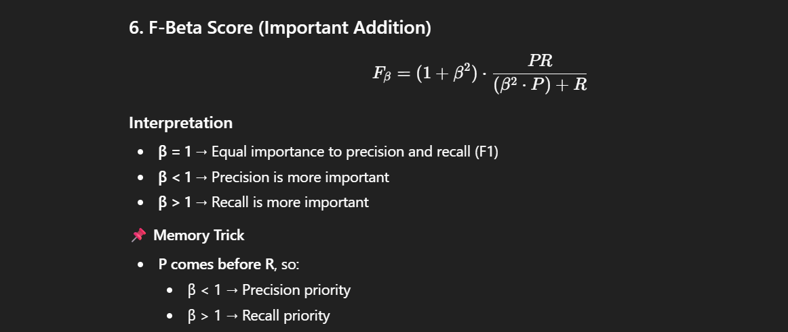
F-beta score formula and interpretation

8.4 ROC Curve and AUC
ROC = plot of True Positive Rate (y-axis) vs False Positive Rate (x-axis) across ALL possible classification thresholds. A good classifier has high TPR and low FPR.
- The diagonal (y = x) is a RANDOM classifier. A curve BELOW the diagonal is worse than random — it is actively predicting the wrong class (flipping its outputs would help!).
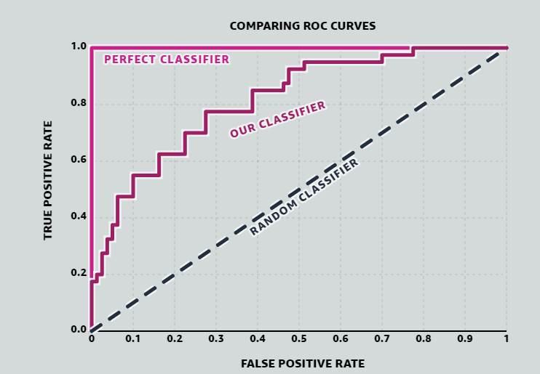
Comparing ROC curves: perfect vs our classifier vs random
- AUC: the area under the ROC curve. 0.5 = random guessing (no discriminative power); 1.0 = perfect separation. A higher AUC means the model is, on average, better at distinguishing positives from negatives — even if individual threshold points vary.
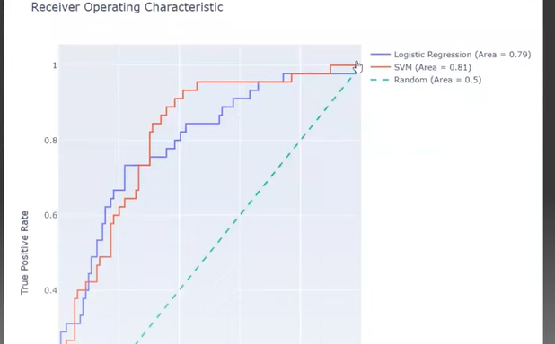
Two real models compared by AUC (Logistic Regression 0.79 vs SVM 0.81)
- Practical recipe: first choose the model with the highest AUC, THEN choose the threshold within that model to get the precision/recall balance your business needs.

8.5 Multi-class Classification
Multi-class = y can take more than 2 values. Two strategy families:

1) Binary transformation
- OvR (One vs Rest): for n classes, build n models — A vs rest, B vs rest, C vs rest... Each outputs a probability; the class with the highest probability wins (ties broken randomly). With 10 classes → 10 models.
- OvO (One vs One): build one classifier for every PAIR of classes — n(n−1)/2 models. Prediction: every classifier votes; majority vote wins. With 10 classes → 45 models, so OvR is much faster in production.
OvO voting example (3 classes)
Classifier A-vs-B votes A; A-vs-C votes A; B-vs-C votes B → final prediction A (2 votes vs 1).

Why can OvR and OvO give different answers on the SAME data?
- Different decision boundaries: OvR learns each class against ALL others combined; OvO separates only two classes at a time.
- Different training data per classifier: each OvO model sees only two classes’ rows; each OvR model sees everything.
- Class imbalance effects: OvR suffers from built-in imbalance (1 class vs many); OvO pairs are usually balanced.

2) Native multi-class classifiers
SVMs, CART/decision trees, KNN, Naive Bayes and neural networks with multi-output layers can handle all classes SIMULTANEOUSLY — finding boundaries that separate each class from all others at once, rather than building separate models.

Multi-class confusion matrix and ROC
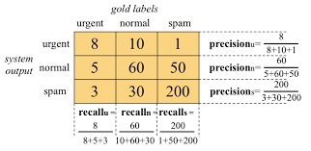
Multi-class confusion matrix with per-class precision and recall
The AUC-ROC curve is natively a BINARY tool; we extend it to multi-class using One-vs-Rest: with classes 0, 1, 2 we draw the ROC of "0 vs not-0", "1 vs not-1", "2 vs not-2" (OvO ROC pairs like 0-vs-1, 0-vs-2, 1-vs-2 are also possible).
Reading per-class AUC
AUC(class 0) = 0.90 → very good at detecting class 0; AUC(class 1) = 0.70 → moderate; AUC(class 2) = 0.55 → poor (barely better than random) — tells you exactly WHERE the model is weak.

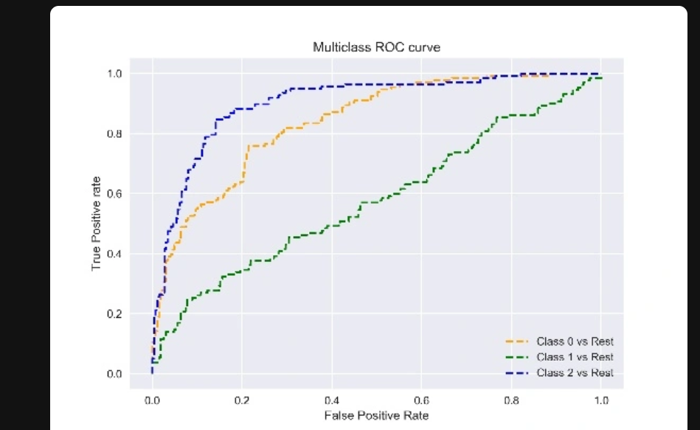
Multi-class ROC: one One-vs-Rest curve per class

Tricky Interview Questions — Part 8
Q: 99.2% accuracy on fraud detection. Impressive?
Not necessarily. If only 0.8% of transactions are fraud, predicting "not fraud" for EVERYTHING also scores 99.2%. On imbalanced data always look at precision, recall, F1 and AUC — never accuracy alone.
Q: Cancer screening vs spam filtering — which metric do you prioritize?
Cancer screening: RECALL (a false negative is a missed cancer — catastrophic; false positives just trigger more tests). Spam filter: PRECISION (a false positive sends a real important email to spam — worse than letting one spam through). Matching the metric to the COST of each error type is the whole point of this question.
Q: What does AUC = 0.8 actually mean, in one sentence?
If you pick one random positive and one random negative example, there is an 80% chance the model assigns the positive a higher score. AUC is a RANKING measure — it is threshold-independent.
Q: My model’s ROC curve is BELOW the diagonal. Is it useless?
Ironically, no — it is consistently wrong, which is information. Inverting its predictions gives AUC = 1 − AUC_old, i.e., a better-than-random model. Usually it signals flipped labels or an inverted score somewhere in the pipeline.
Q: Why is F1 the harmonic mean instead of the arithmetic mean?
The harmonic mean collapses toward the SMALLER value. Precision 1.0 with recall 0.01 averages to 0.505 arithmetically (looks okay) but ≈ 0.02 harmonically (correctly terrible). F1 forces the model to be good at BOTH.
Q: High AUC but business results are bad. How?
AUC measures ranking across all thresholds, but production uses ONE threshold. The chosen cutoff may sit in a bad region (e.g., terrible precision at the recall you need), or the class distribution / costs in production differ from the test set. Always follow AUC selection with explicit threshold tuning on precision/recall.

Part 9 — Unsupervised Learning: Clustering
There is no single "best" clustering method — the choice depends on data distribution, density variation, cluster shape and whether you know the number of clusters in advance.

9.1 K-Means
- Partitions data into K clusters. Algorithm: (1) choose K; (2) randomly initialize K centroids; (3) assign each point to its nearest centroid; (4) update each centroid as the MEAN of its assigned points; (5) re-measure distances and re-assign; repeat until centroids stop changing.
- Limitations: must specify K; sensitive to outliers (the mean gets dragged); assumes spherical clusters; results vary between runs (random initialization).

K-Means++ (smart initialization)
- Identical algorithm — only the INITIALIZATION is smarter: pick the first centroid randomly; for every other point measure the distance to its nearest existing centroid; pick the next centroid from the data points with probability PROPORTIONAL TO THE SQUARED DISTANCE. Every following centroid (2nd...Kth) is chosen this way → initial centroids spread out, far fewer bad runs.

K-Medoids
- Medoid: an ACTUAL data point in the cluster whose total distance to all other points in the cluster is minimal (vs the centroid, which is an average and may not be a real point).
- Algorithm: choose K data points as initial medoids; assign non-medoid points to the nearest medoid; for each cluster compute the total distance cost and swap to whichever point gives the lowest cost as the new medoid; repeat until no change.
- Strength: robust to outliers and noise — extreme values cannot drag the cluster centre because the centre must be a real point. Weakness: computationally expensive.

Choosing K
＋ Added concept: Your notes flagged "must specify K" as a limitation but never said HOW to choose it — interviewers always follow up with this. Elbow method: plot inertia (within-cluster sum of squared distances) versus K; inertia always falls as K grows, but at the "elbow" the improvement suddenly flattens — pick that K. Silhouette score: for each point, compare its cohesion (distance to its own cluster) with its separation (distance to the nearest other cluster); score ranges −1 to +1; pick the K with the highest average silhouette. The elbow is quick and visual; silhouette is more rigorous.

9.2 DBSCAN
Density-Based Spatial Clustering of Applications with Noise — unsupervised, density-based. Assumes clusters are dense regions separated by low-density regions.
- Parameters: ε (epsilon) = neighbourhood radius; MinPts = minimum points to form a dense region.
- Point types: Core point — at least MinPts within ε. Border point — fewer than MinPts but within ε of a core point. Noise — not reachable from any core point (gets NO cluster, label −1).
- Process: pick an unvisited core point → start a cluster → add all density-reachable core points → add border points (border points do not expand the cluster further) → repeat for remaining points.
- Pros: arbitrary-shaped clusters; no need to specify the number of clusters; built-in outlier detection. Cons: sensitive to ε; struggles in high dimensions.

9.3 Mean-Shift Clustering
- Centroid-based; discovers the number of clusters automatically. Place a circular window (kernel) of radius r on a data point; compute the mean of the points inside; shift the window centre to that mean; repeat with multiple sliding windows until all points fall within stable windows. Overlapping windows: the one containing more points prevails.
- Pros: no K needed; handles arbitrary shapes. Cons: choosing window size r is hard; computationally expensive — O(n²).
Method | Need K? | Cluster shape | Handles outliers | Key weakness
K-Means | Yes | Spherical | Poorly (mean dragged) | Random init, outliers
K-Medoids | Yes | Spherical-ish | Well (real-point centre) | Expensive
DBSCAN | No | Arbitrary | Marks them as noise | Choosing ε, high-dim
Mean-Shift | No | Arbitrary | Reasonable | O(n²), choosing r

Tricky Interview Questions — Part 9
Q: K-Means gives different clusters every run. Bug?
No — random centroid initialization makes K-Means converge to different LOCAL optima. Fixes: K-Means++ initialization, run multiple times and keep the lowest-inertia result (n_init in sklearn), or fix the random seed for reproducibility.
Q: Why does K-Means fail on ring/moon-shaped data, and what works instead?
K-Means assigns by distance to a centroid, which implicitly carves space into convex, roughly spherical cells — a ring’s centroid sits in its empty middle. Density-based methods (DBSCAN) or spectral clustering follow the actual shape of dense regions and handle rings/moons.
Q: K-Means vs K-Medoids in one sentence each — when to prefer which?
K-Means: faster, uses the mean → preferred for large, clean datasets. K-Medoids: centre is a real data point and total distance (not squared) is minimized → preferred when outliers exist or when the "centre" must be an actual interpretable example.

Part 10 — Anomaly / Outlier Detection

10.1 Statistical Methods

Z-Score
- Measures how many standard deviations a point is from the mean. Assumes the data is normally distributed. Rule of thumb: |Z| > 3 → outlier.
- Limitation 1 — sensitive to the outliers themselves: a massive outlier pulls the MEAN toward itself and inflates the SD, which "masks" the outlier — it ends up looking normal.
- Limitation 2 — the threshold 3 is arbitrary: in very large datasets some extreme values are EXPECTED naturally.

Modified Z-Score
Replaces mean with the MEDIAN and SD with the MAD (median absolute deviation) — both are unaffected by extreme values. Rule: |modified Z| > 3.5 → outlier. Crucially, it does NOT assume normality, so it works for long-tailed, asymmetric and unknown distributions.
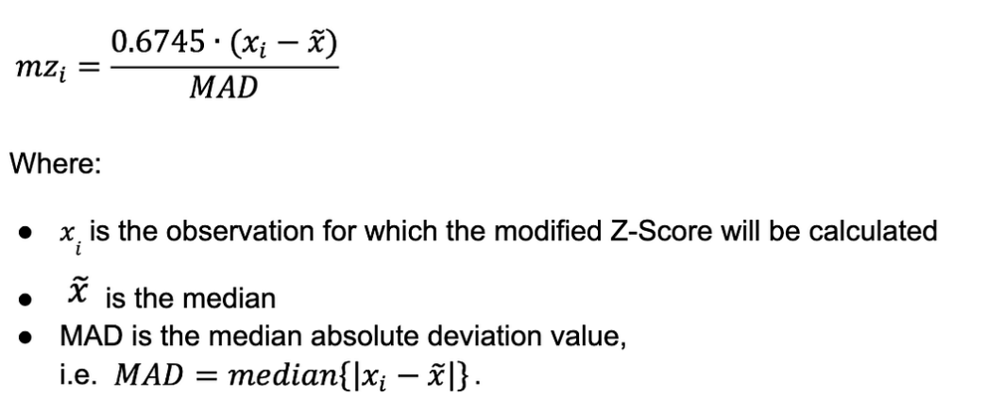
Modified Z-score: 0.6745 × (x − median) / MAD

IQR (Interquartile Range)
- Distribution-free. Q1 = 25th percentile, Q3 = 75th percentile, IQR = Q3 − Q1.
- Outlier bounds: below Q1 − 1.5×IQR or above Q3 + 1.5×IQR.
Example
Salaries: Q1 = 40k, Q3 = 80k → IQR = 40k. Bounds: 40k − 60k = −20k and 80k + 60k = 140k. A salary of 500k → outlier; 130k → not.

10.2 Density-Based: Local Outlier Factor (LOF)
- Compares the LOCAL density of a point with the density of its neighbours — an outlier is a point whose density is much lower than its neighbours’.
- k (neighbours): typical 10–30. Larger k → more global view; smaller k → more local sensitivity.
- LRD (Local Reachability Density): inverse of the average reachability distance to neighbours. Low LRD → point sits in a sparse region.
- LOF score = (average LRD of neighbours) / (LRD of the point). LOF ≈ 1 → normal; LOF > 1 → lower density than neighbours → potential outlier; higher = stronger anomaly.

10.3 Clustering-Based Approaches
- K-Means based: outliers = points far from their cluster centroid, or members of tiny/sparse clusters. Common recipe: apply Z-score or IQR to distances WITHIN each cluster. Limitations: must choose K, assumes spherical clusters.
- kNN distance: anomaly score = (average) distance to the k nearest neighbours. Normal points are close to neighbours; anomalies are isolated and far.
- DBSCAN: points labelled −1 (noise) are the outliers — anomaly detection comes built in. Bonus: no K needed, arbitrary shapes.

10.4 One-Class SVM (boundary-based)
- Trained on NORMAL data only — learns a boundary around normal observations (technically: a decision function separating normal data from the origin in feature space).
- New point inside the boundary → inlier; outside → outlier.
- Unsupervised/semi-supervised; kernel-based (RBF most common); SENSITIVE to feature scaling.

10.5 Isolation Forest
Builds many random trees; at each split it randomly selects a feature AND a random split value, then counts how many splits are needed to ISOLATE each point (path length).
- Key idea: fewer splits → easier to isolate → MORE anomalous. Points deep inside dense regions need many splits → normal.
- Contamination: a threshold selector — you tell the model what fraction of the data to flag, and it returns the most anomalous X% by score (you should verify by checking the anomaly score distribution).
✔ Correction: Wording fix: the flagged points are those with the HIGHEST anomaly scores / SHORTEST isolation paths (the original note said "bottom X%", which reads backwards — it is the top-X% most anomalous fraction).
Fraud-detection notes from practice (kept from your sheet)
Transaction amounts are heavily right-skewed → apply a log transform to transaction_amount.
Apply RobustScaler to all columns (median/IQR-based → outlier-resistant).
No labels (unsupervised) → validate by inspecting the anomaly-score distribution and by BACKTESTING on confirmed historical fraud cases.
Business rules can be layered on top, e.g., force all transactions above a high amount threshold (top 10%) to appear in the anomaly output.

Tricky Interview Questions — Part 10
Q: Why can the plain Z-score MISS a huge outlier?
Masking: the outlier itself inflates the mean and the standard deviation used to compute Z. With the statistics distorted toward it, its own Z-value shrinks below 3 and it looks normal. Median/MAD (modified Z) or IQR are immune because medians ignore extremes.
Q: A point is globally normal but locally strange — which detector catches it?
LOF. A point with moderate values sitting just outside a very tight cluster has a far lower density than its neighbours → LOF ≫ 1, while global methods (Z-score, IQR) see nothing unusual. That local-vs-global contrast is LOF’s entire purpose.
Q: Why is Isolation Forest fast compared to distance-based detectors?
It never computes pairwise distances. Random splits isolate anomalies in O(n log n)-ish time, and trees are independent (parallelizable). kNN/LOF need neighbour searches, which get expensive as n and dimensionality grow.
Q: You set contamination = 0.05. What exactly happens?
The model does NOT "find" 5% anomalies — it RANKS all points by anomaly score and labels the top 5% as anomalous, period. If the real anomaly rate is 1%, you generate false alarms; if it is 10%, you miss half. Contamination is your assumption, not the model’s discovery — sanity-check it against the score distribution.

Part 11 — Git & GitHub
- Git: a version control system — helps teams manage changes to source code over time.
- GitHub: a cloud-based hosting service for managing Git repositories.

11.1 The Three Areas of Git
- Working Directory: where you modify files.
- Staging Area (Index): a "box" where you prepare the next commit.
- Local Repository: where commits are stored permanently.
Flow example
Edit file → git add file (working dir → staging) → git commit -m "msg" (staging → local repo) → git push origin main (local repo → remote).

11.2 Core Commands
- git init — initializes a repository (creates the .git folder). Default branch is now usually main (older versions: master). Undo with rm -rf .git.
- git add <file> / git add . — move file(s) to the staging area so changes can be tracked/committed.
- git commit -m "message" — record the staged snapshot in the local repository.
- git push origin main — upload commits to the remote branch. -u sets the upstream so future pushes can be just git push.
- git log — view commit history and commit IDs.
- git status — untracked/modified files show in red; staged ("changes to be committed") show in green.
- git diff — "show me what I changed but haven’t committed yet" (unstaged changes vs last snapshot).
- .gitignore — list file names (wildcards allowed, e.g., *.log) that git status / tracking should ignore.

11.3 Remotes and "origin"
- origin is just the DEFAULT NAME for a remote repository URL — a convention, not magic. You could name it anything: git remote add myremote <url>.
- It appears automatically when you git clone <url> (git silently runs git remote add origin <url>), or you add it manually for a locally created repo.
- git remote — list remotes; git remote -v — show stored URLs; git remote set-url origin <url> — change the URL.
✔ Correction: The note had "git remote -V" (capital V). The flag is lowercase: git remote -v (verbose). Capital -V is not a valid option here.

11.4 Undoing Things: restore, revert, reset
- git restore <file> — discard UNCOMMITTED changes in the working directory (file goes back to the last committed version).
- git restore --staged <file> — UNSTAGE: move a file out of the staging area back to "modified" (before you commit).
✔ Correction: The note said restore "moves from staging area to local repository" — that is what COMMIT does. restore goes the other way: plain restore throws away working-directory edits; restore --staged un-stages a file. Mixing these up in an interview is costly.
- git revert <commit-id> — SAFELY undoes a commit by creating a NEW commit that reverses it. History is preserved → safe on shared branches.
- git reset — REWRITES history by discarding commits (dangerous on shared branches):
Command | Commit | Staging area | Working files
git reset --soft HEAD~1 | Removed | Changes kept (staged) | Untouched
git reset --mixed HEAD~1 (default) | Removed | Cleared (unstaged) | Untouched
git reset --hard HEAD~1 | Removed | Cleared | Changes DELETED
- HEAD = current commit; HEAD~1 = one commit before; HEAD~2 = two before.

11.5 Tags
- Tags are human-readable labels attached to specific COMMITS — never to files or the staging area — usually marking releases/versions (v1.0, v2.1).
- Created after a commit. Tags are NOT pushed automatically: git push origin --tags. Later you can inspect everything specific to that tag.

11.6 clone vs fetch vs pull
- clone: downloads the ENTIRE project, creates a new folder, sets up git automatically. Used once.
- fetch: downloads the latest changes from the remote but does NOT touch your files and does NOT merge — you look first, merge later.
- pull: fetch + merge in one step — like downloading the latest version of a shared document and updating your copy.

11.7 Branching, Merging & Rebase
A branch is an independent line of development diverging from the main codebase — work on features, fixes or experiments without affecting main. Changes stay isolated until merged.
git branch # list branches
git branch abc # create branch
git checkout abc # switch branch
git checkout -b xyz # create + switch
git branch -d abc # delete branch (safe)
git branch -D abc # force delete
git diff branchA..branchB # line-by-line changes between branches
- Merging: combine changes from one branch into another (typically feature → main). Run git merge <branch> FROM the branch you want to merge INTO.
- Merge conflict: git cannot auto-combine — usually because two people (or two branches) modified the SAME LINE of the SAME FILE. You resolve manually, then commit.
- Rebase: moves/replays your commits ON TOP OF another branch. Merge creates a new commit tying two histories together; rebase REWRITES history into a straight line.

Tricky Interview Questions — Part 11
Q: revert vs reset — when is each the right tool?
revert: makes a NEW commit that undoes an old one — history is preserved, so it is the only safe choice on shared/pushed branches. reset: deletes commits from history — fine for cleaning up LOCAL commits you have not pushed, dangerous after pushing (teammates’ history breaks).
Q: merge vs rebase — what is the actual trade-off?
Merge keeps the true history (including the fork and a merge commit) — honest but messy graph. Rebase rewrites your commits onto the tip of the other branch — clean linear history but FALSIFIED timestamps/parents. Golden rule: never rebase commits that have already been pushed and shared.
Q: fetch vs pull — why would a careful developer prefer fetch?
pull = fetch + immediate merge: remote changes hit your working state instantly, possibly causing surprise conflicts. fetch downloads but changes nothing, letting you inspect (git log origin/main, git diff) and merge deliberately.
Q: git reset --hard deleted my work. Truly gone?
Often recoverable: git reflog records where HEAD has been, even for "deleted" commits, so git reset --hard <reflog-id> can resurrect them (for a limited time, until garbage collection). Uncommitted working-directory changes wiped by --hard, however, ARE gone — which is why --hard deserves fear.

